Row 2 :

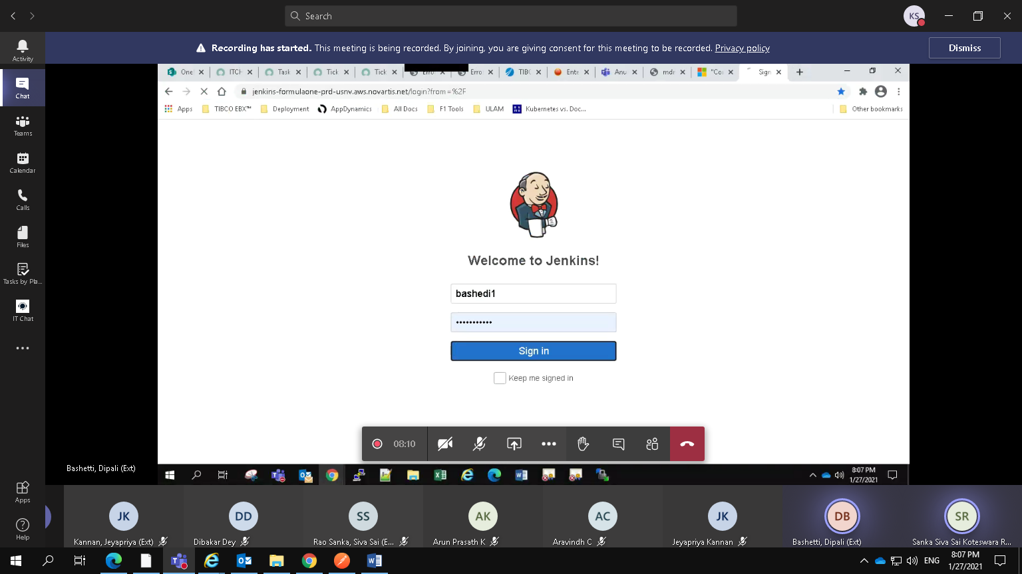

Rown No 3:Verify and run the release job in below path

<https://jenkins-formulaone-prd-usnv.aws.novartis.net/job/MDM/job/novartis-mdm-fairifier/job/BuildPipeline/job/mdm-novartis-mdm-fairifier-build-pipeline/>

Actual Results:

The release job executed successfully

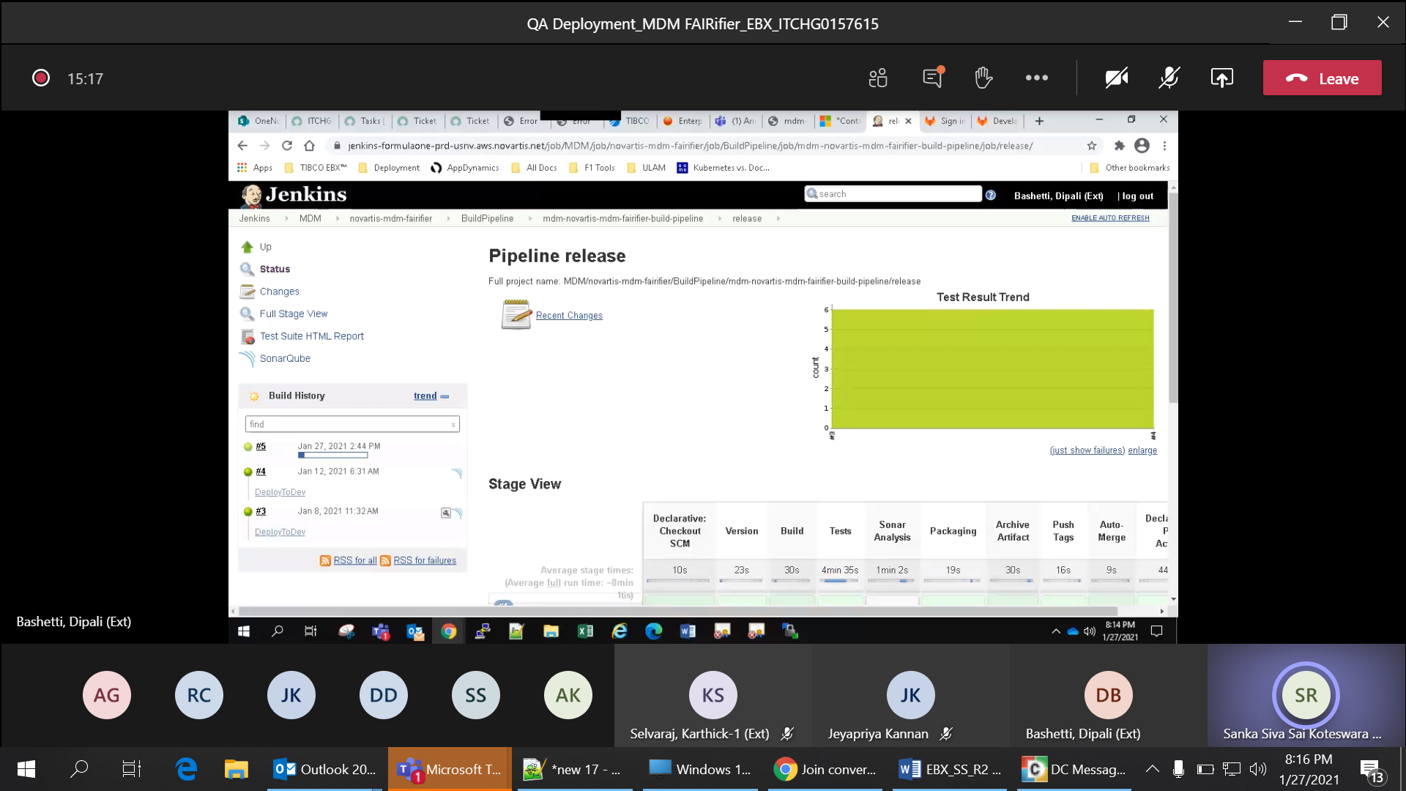

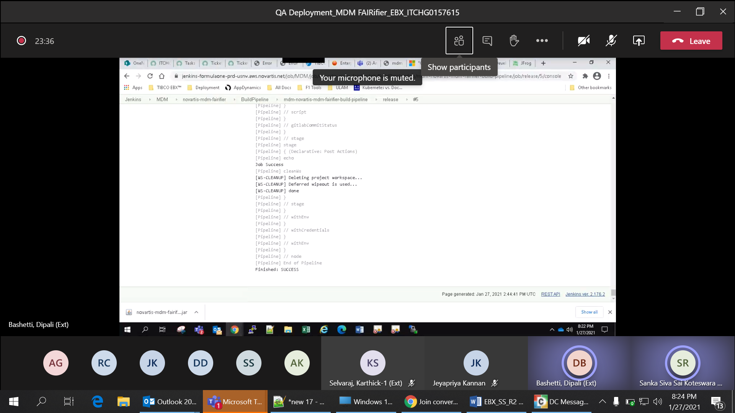

Row No 4:

Verify the latest code from git repository is deployed in EBX server

git URL: <https://gitlab.f1.novartis.net/mdm/eu-non-gxp/novartis-mdm-fairifier/-/tree/develop>

Actual Results:

Latest code is deployed in EBX Server

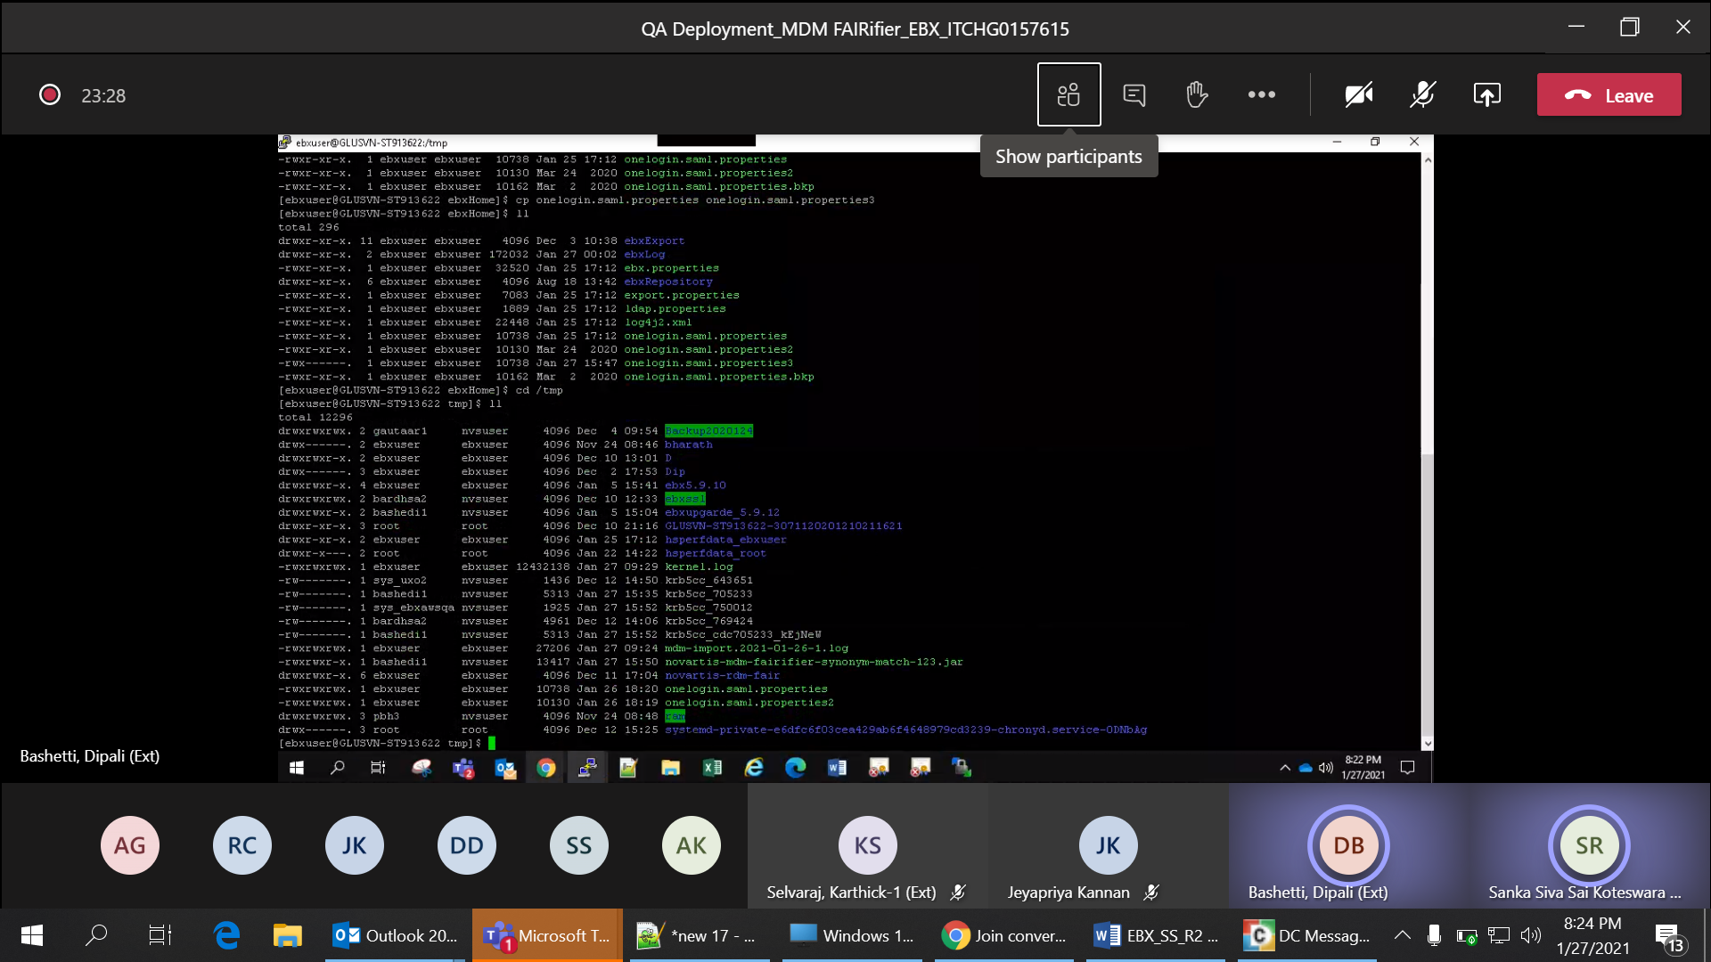

Row no : 5 Verify project requirement specific configuration tables EmailDataSet, FairifierConfig, elastic_DB_parameter,Synonym_Dataset, REFERENCE_DATASET, Sites are deployed in EBX server using its XSD

Actual Results:

Project requirement specific configuration tables EmailDataSet, FairifierConfig, elastic_DB_parameter,Synonym_Dataset, REFERENCE_DATASET, Sites is deployed in EBX server using its XSD

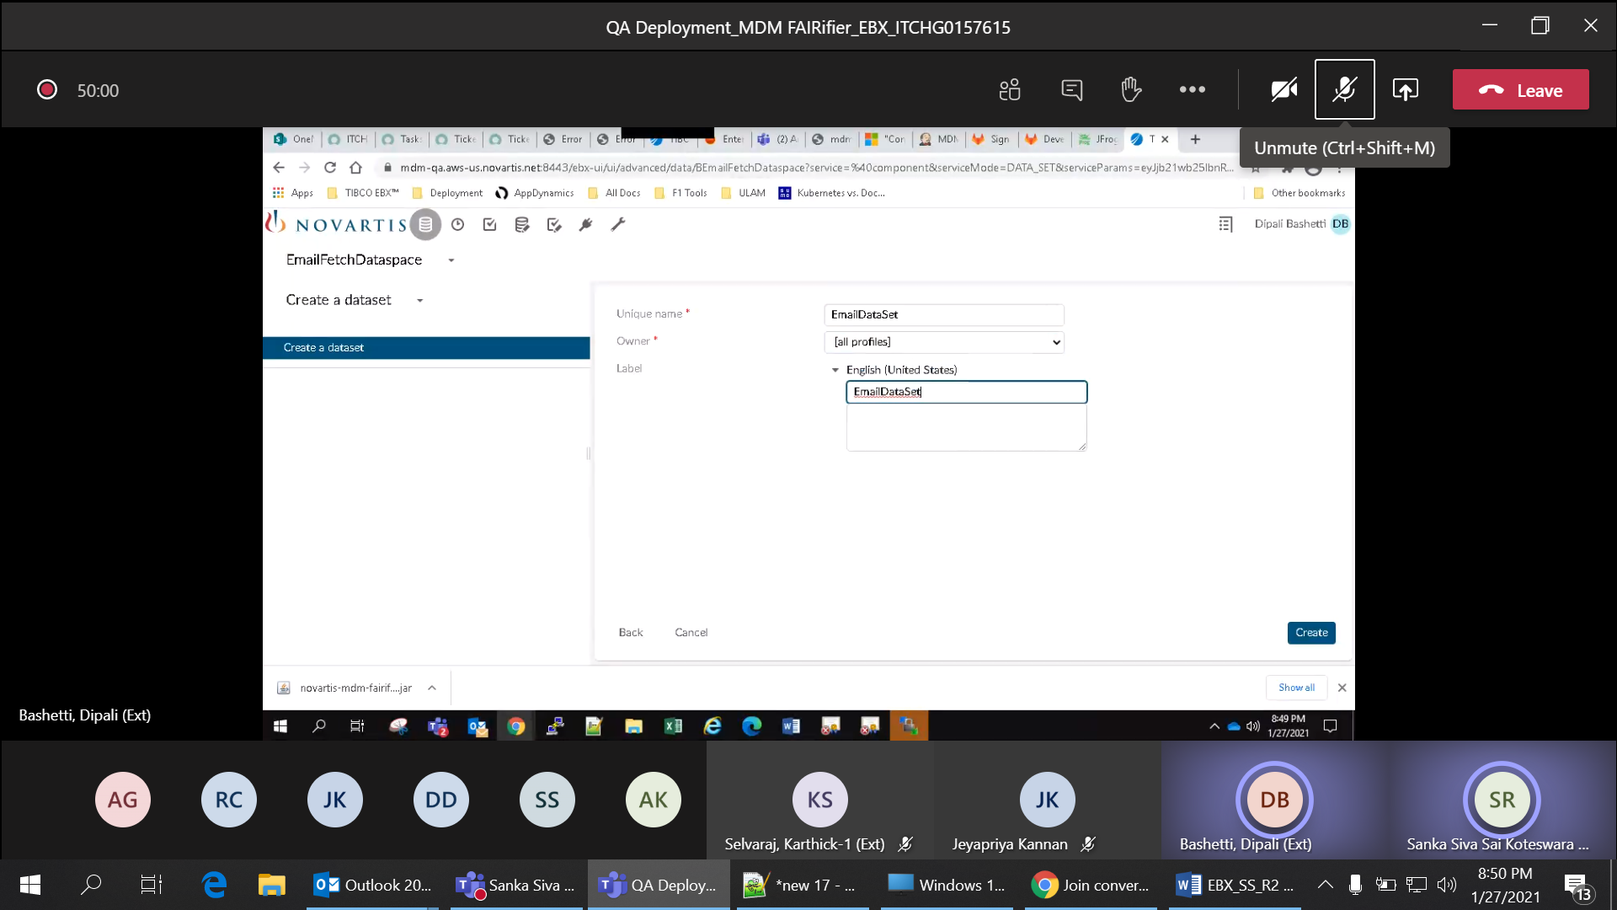

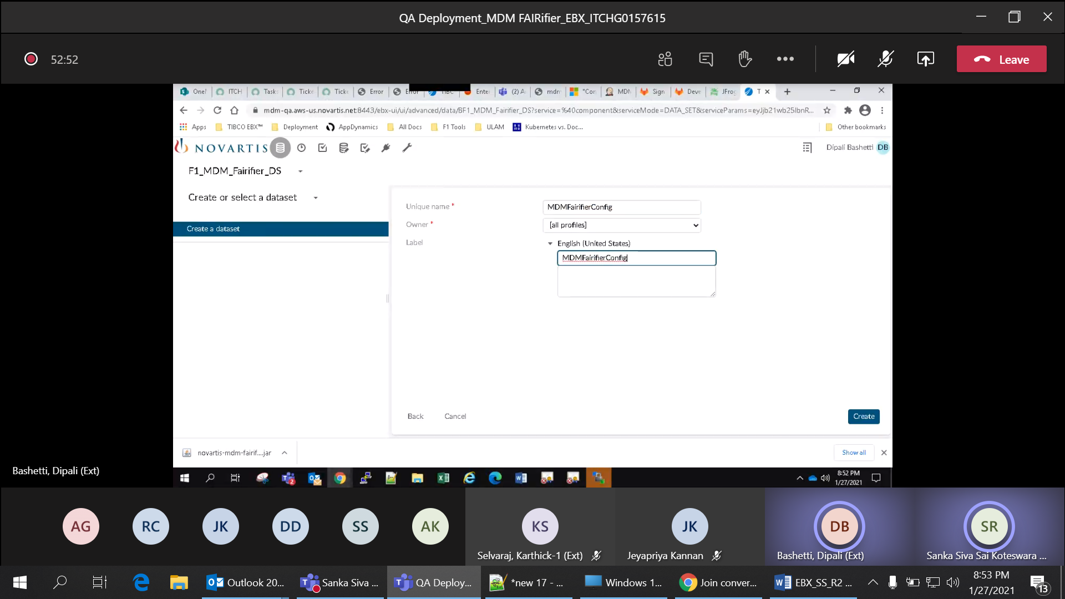

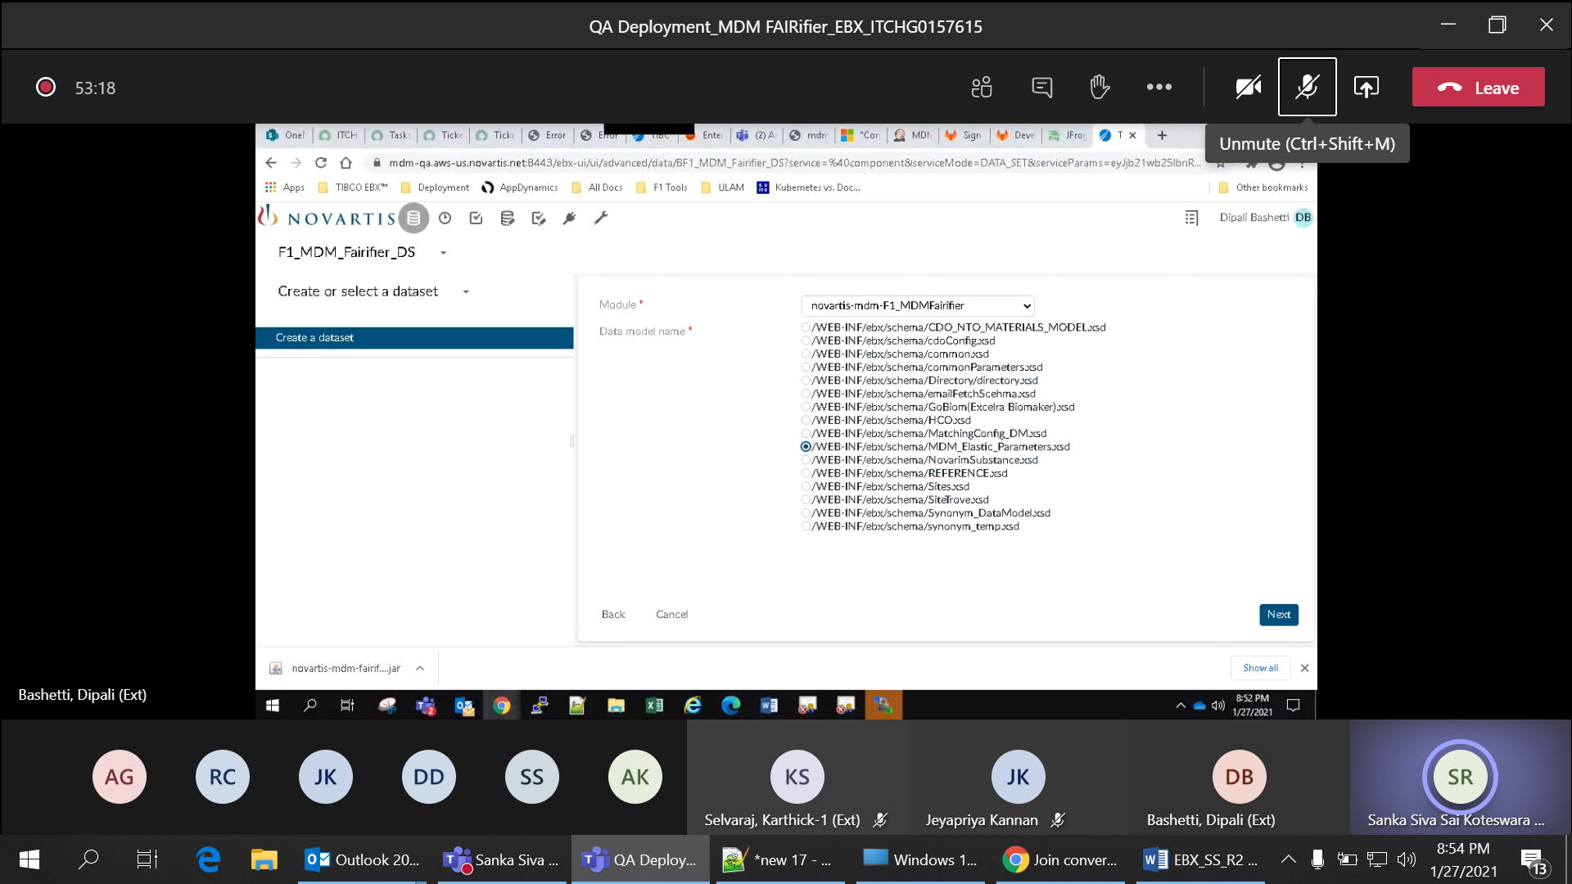

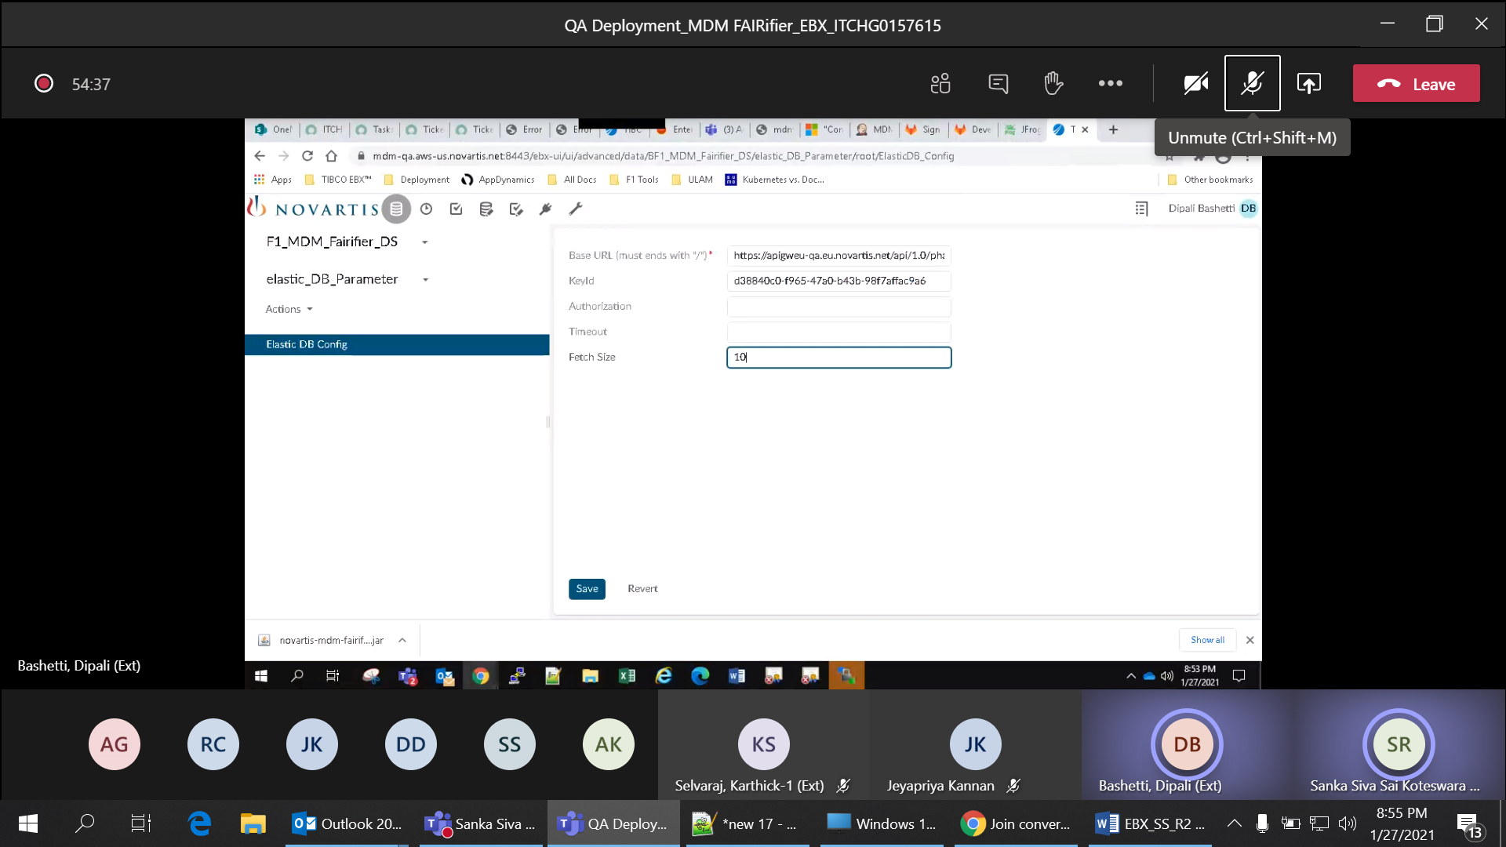

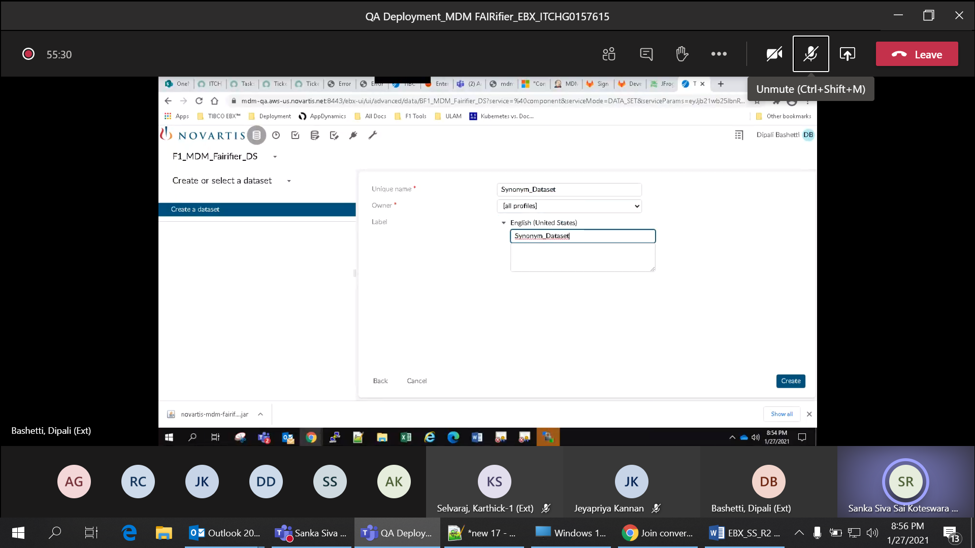

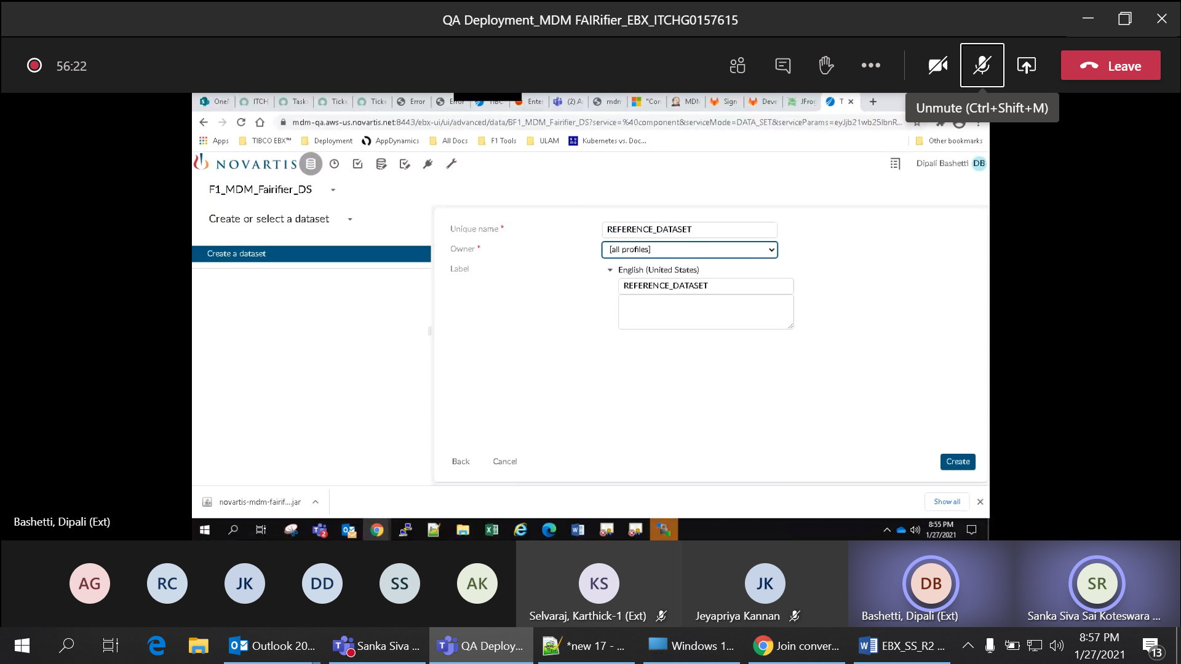

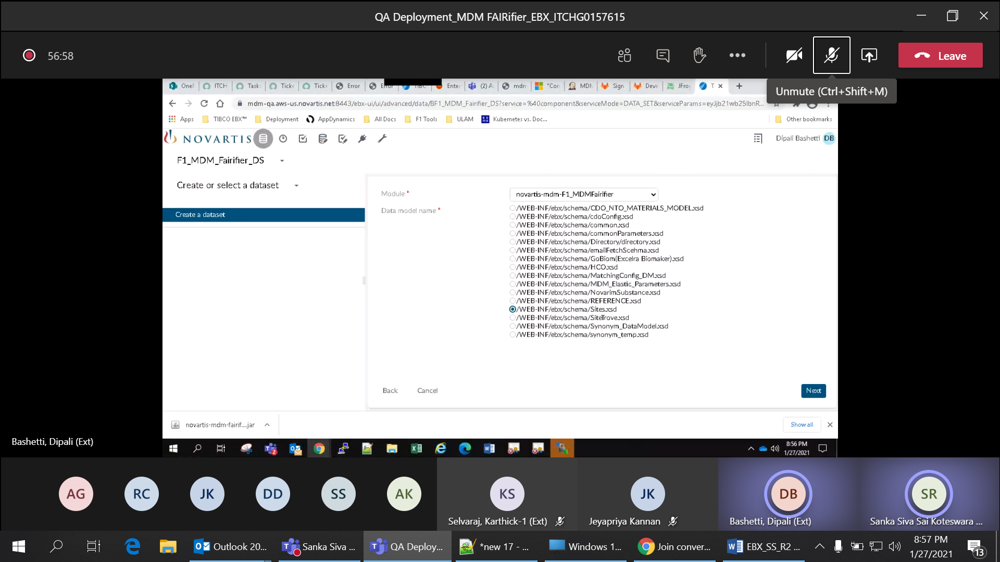

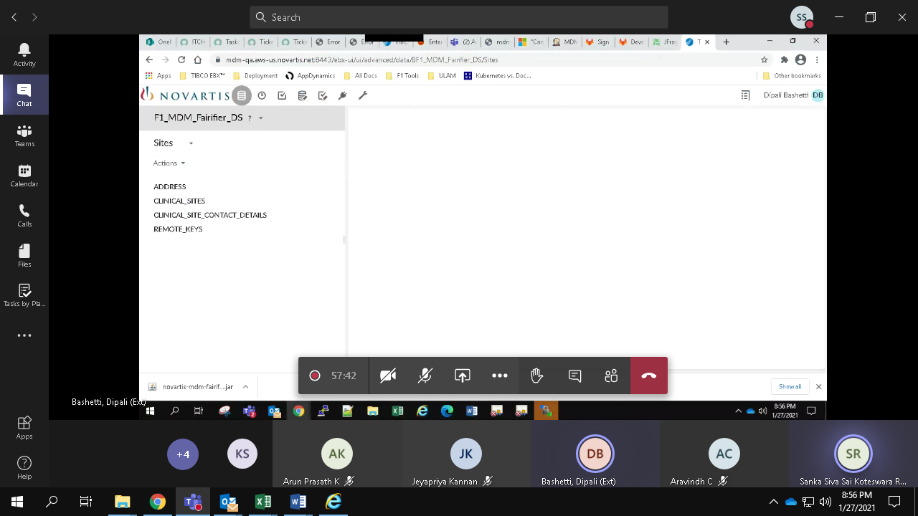

Row No 6:

Verify workflow module configuration is created with workflow name -'SingleTableFairifierWorkflow', module - 'novartis-mdm-F1_MDMFairifier', data context names - dataspace,dataset,tablepath,recordXpath

Actual Results:

workflow module configuration is created with workflow name -'SingleTableFairifierWorkflow', module - 'novartis-mdm-F1_MDMFairifier', data context names - dataspace,dataset,tablepath,recordXpath

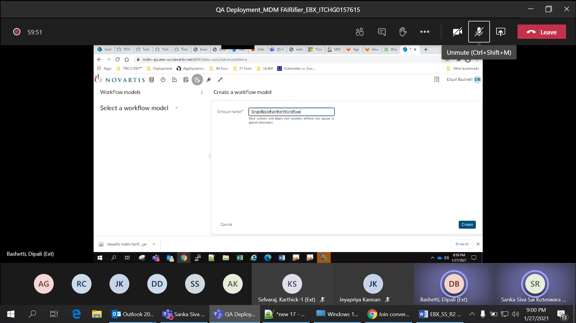

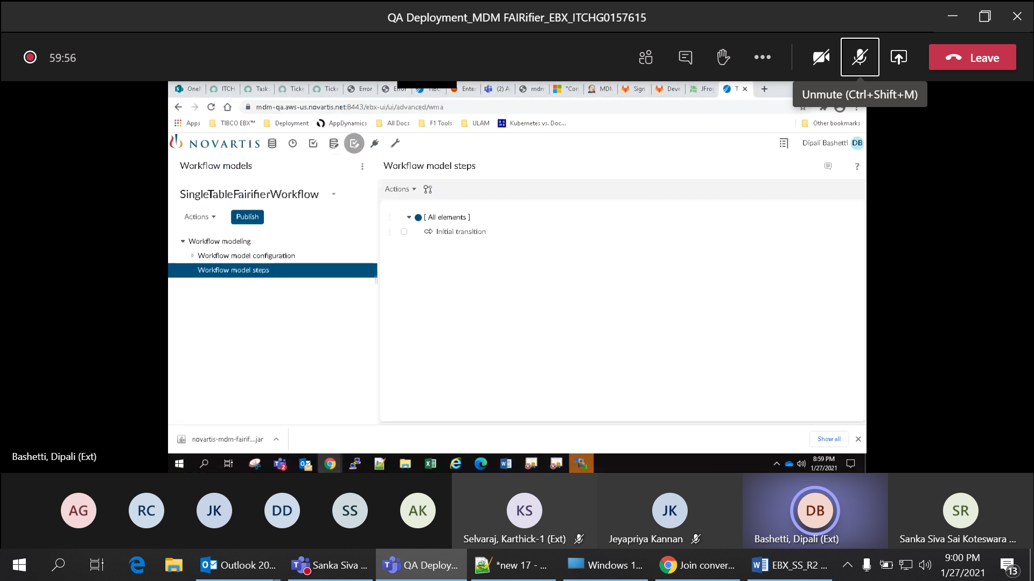

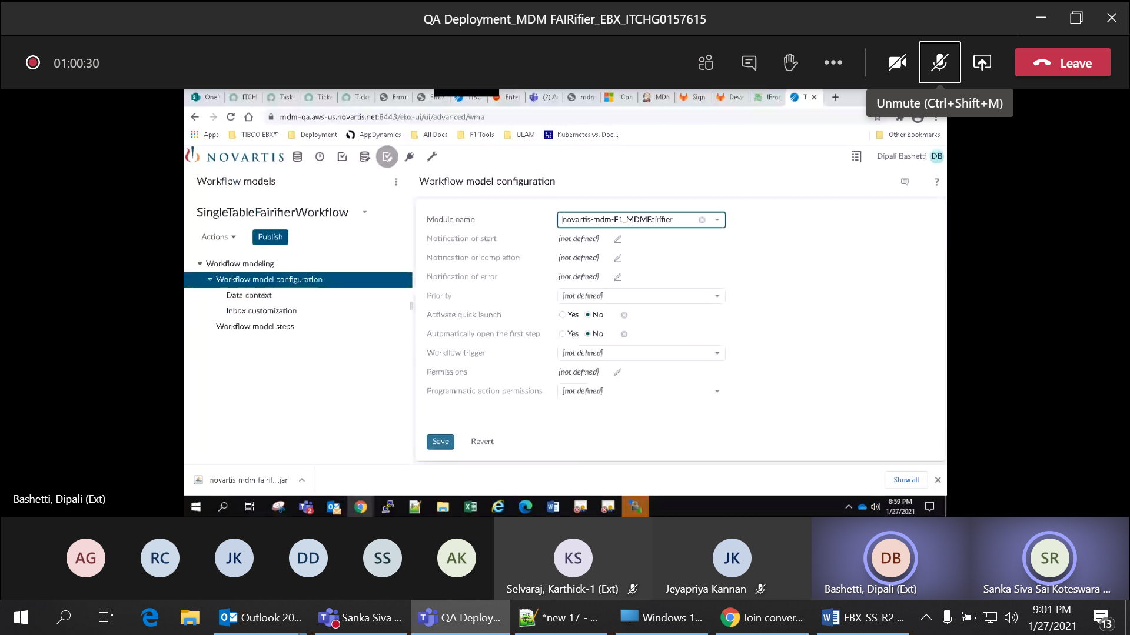

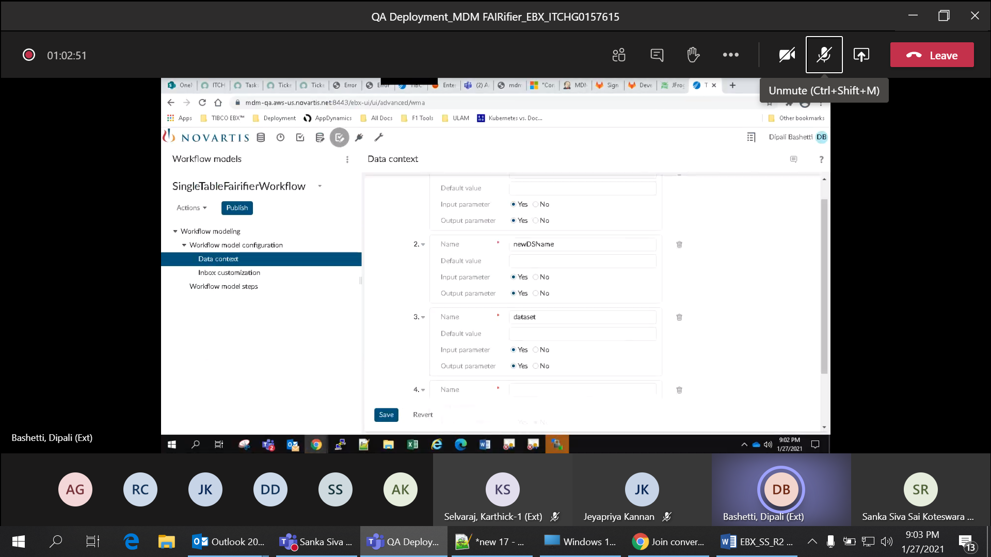

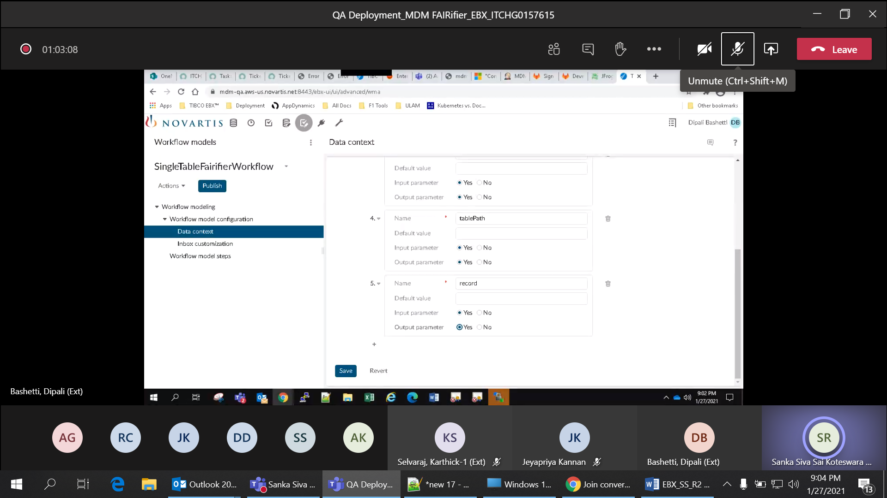

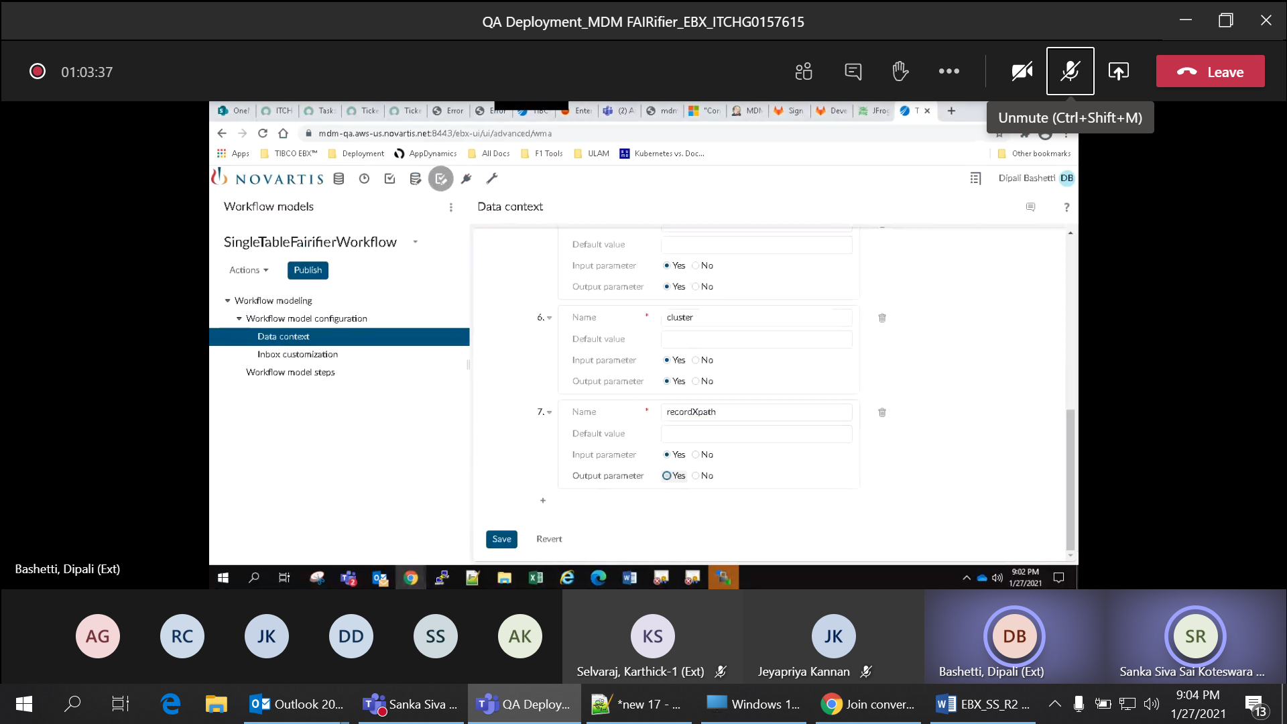

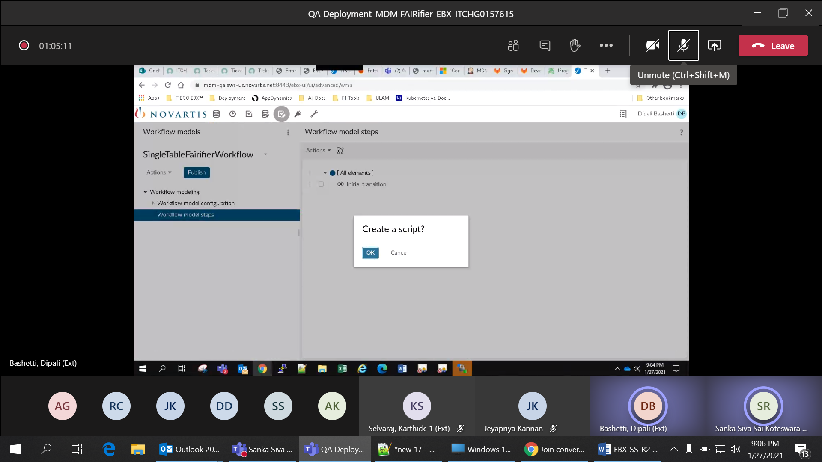

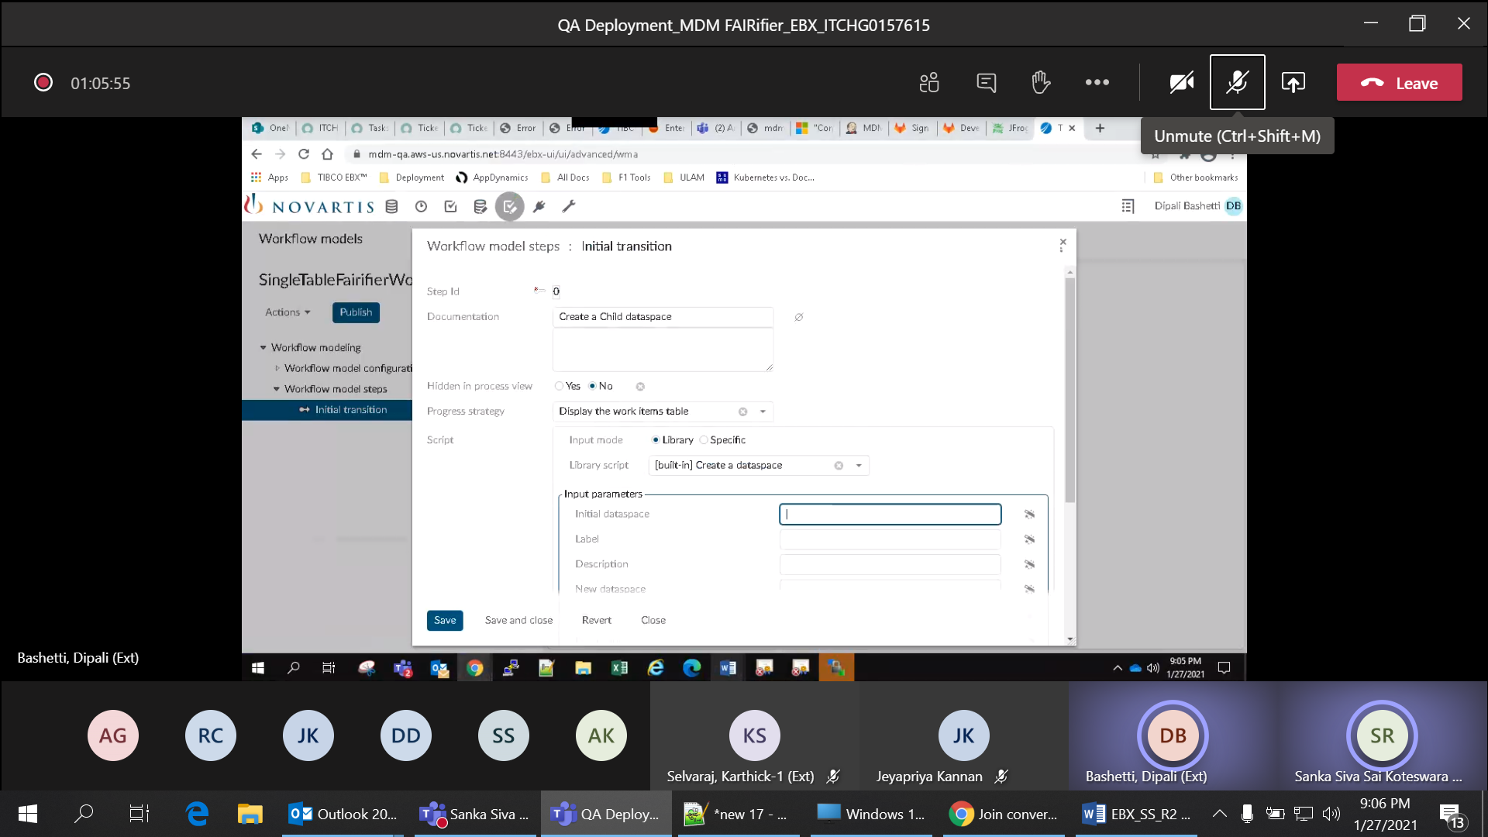

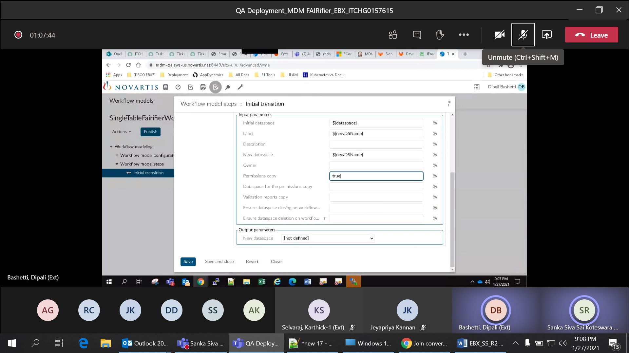

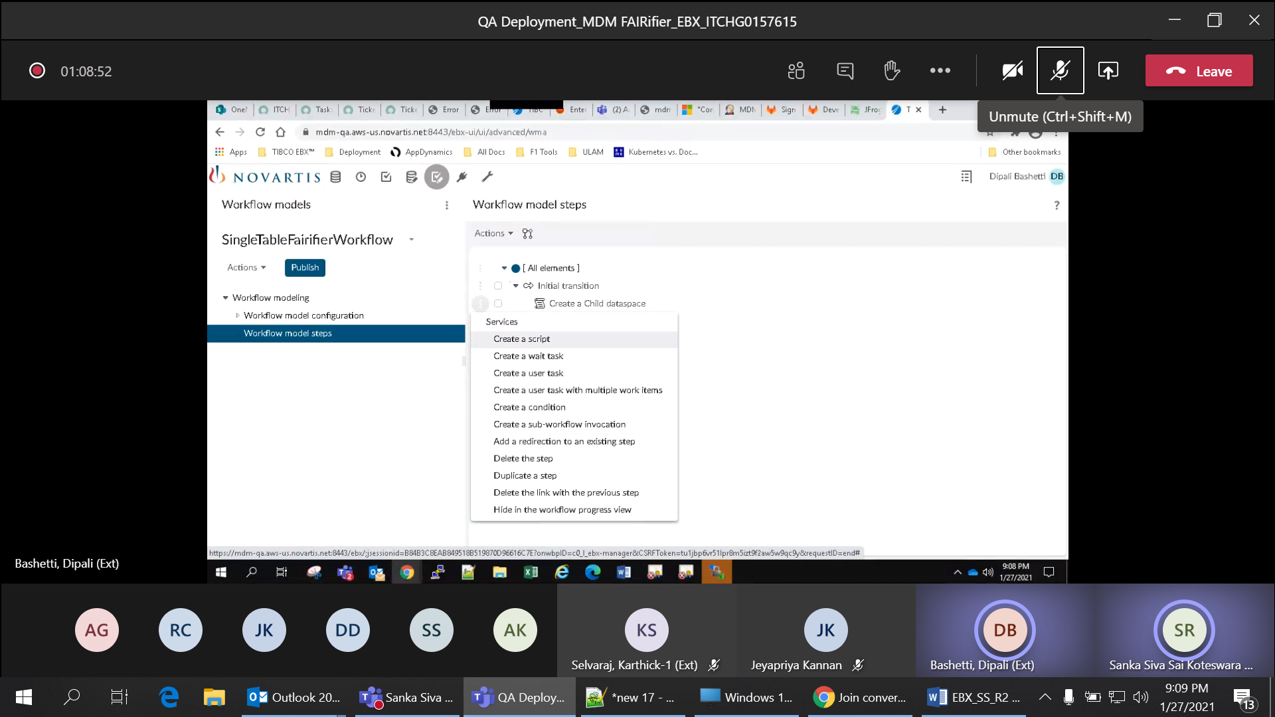

Row No 7: Verify a script task is created for child dataspace creation for 'SingleTableFairifierWorkflow'

Actual:

Script task is created for child dataspace creation for 'SingleTableFairifierWorkflow'

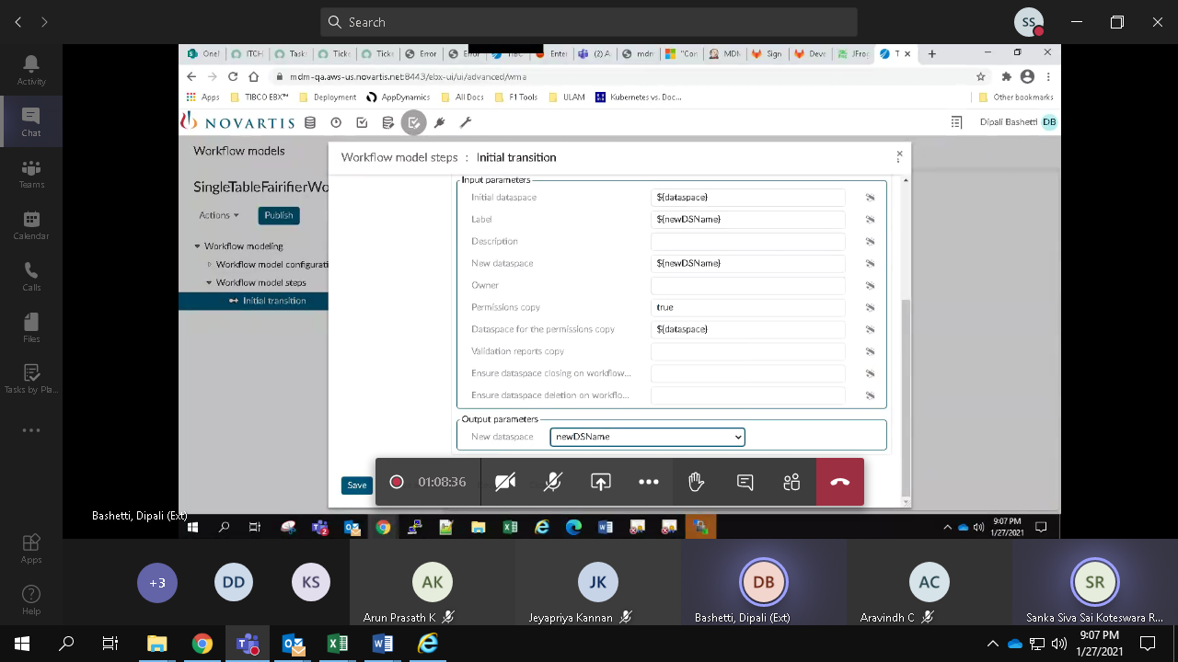

Row No 8: Verify records are created programmatically by the script and data context variables are updated

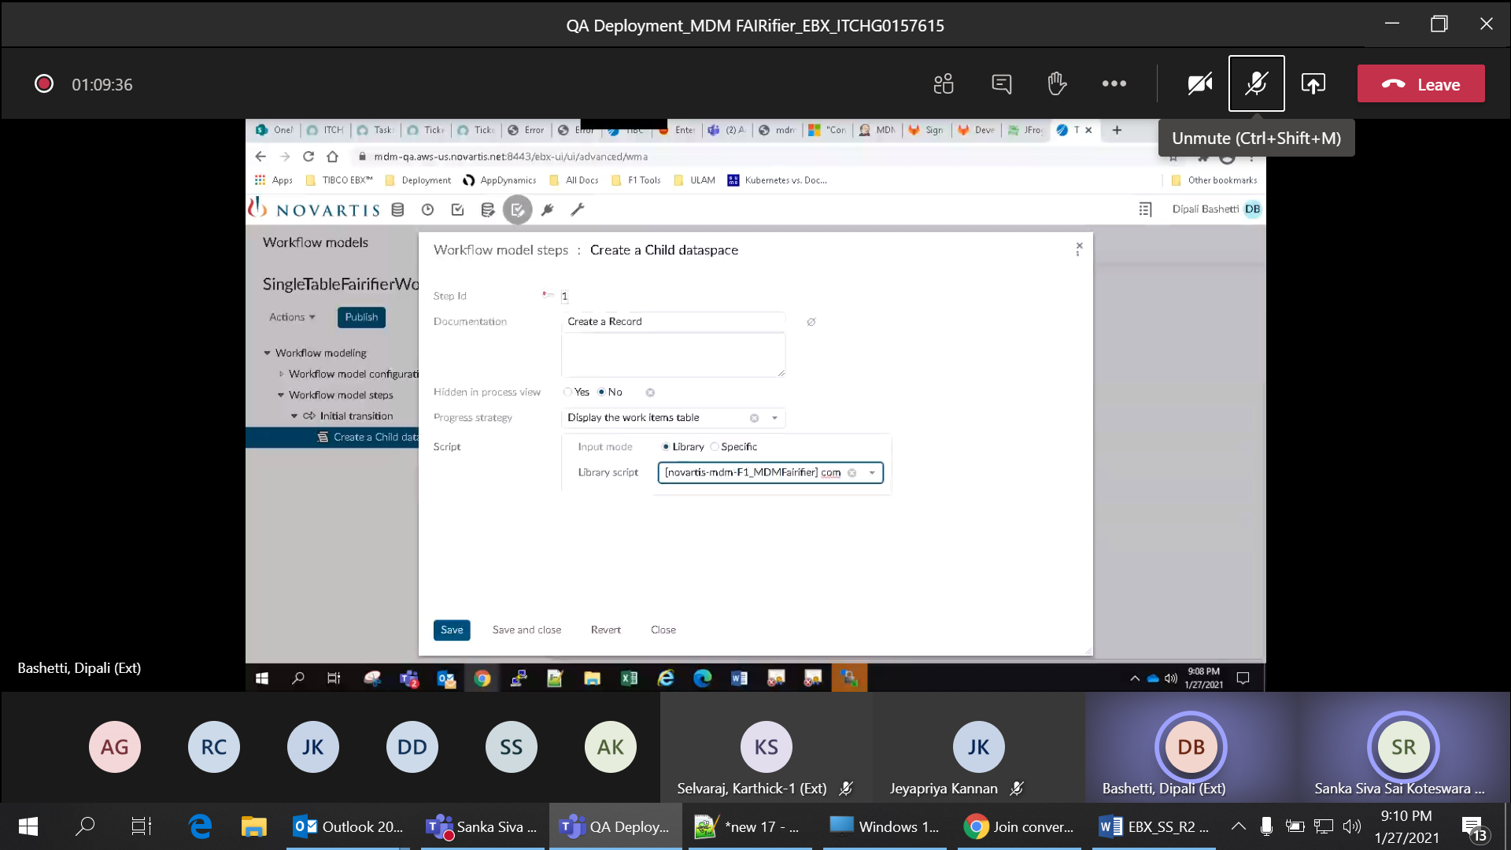

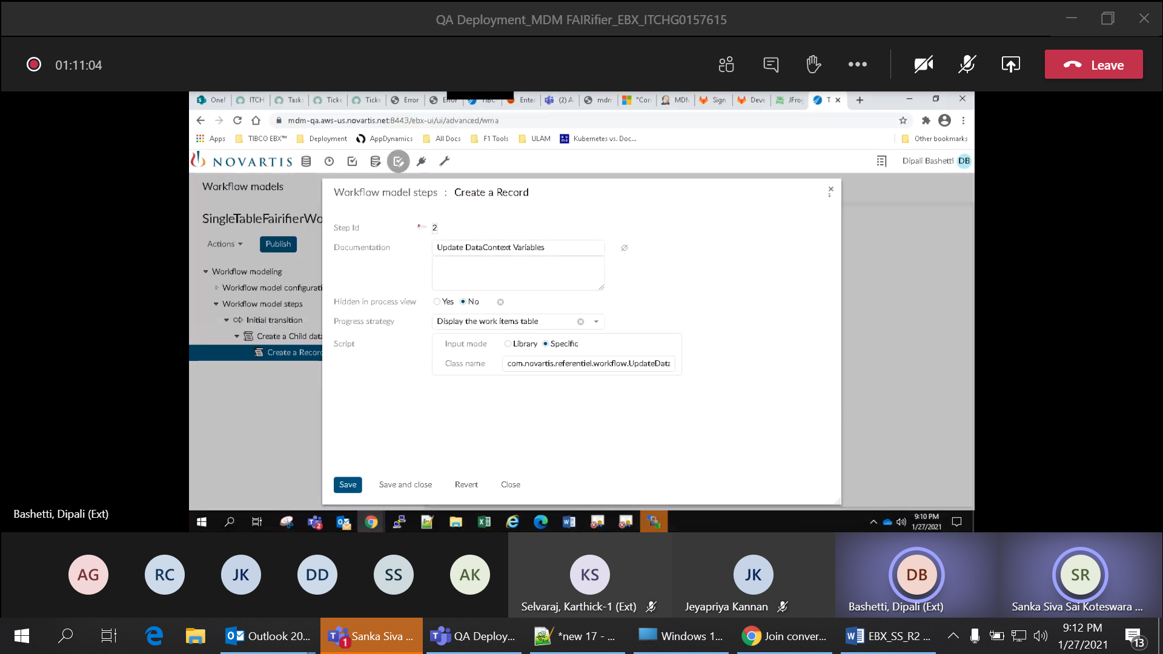

Row no 9: Verify data quality stewardship is created by the script task with service 'ebx-addon-daqa:merge view' and required input parameters

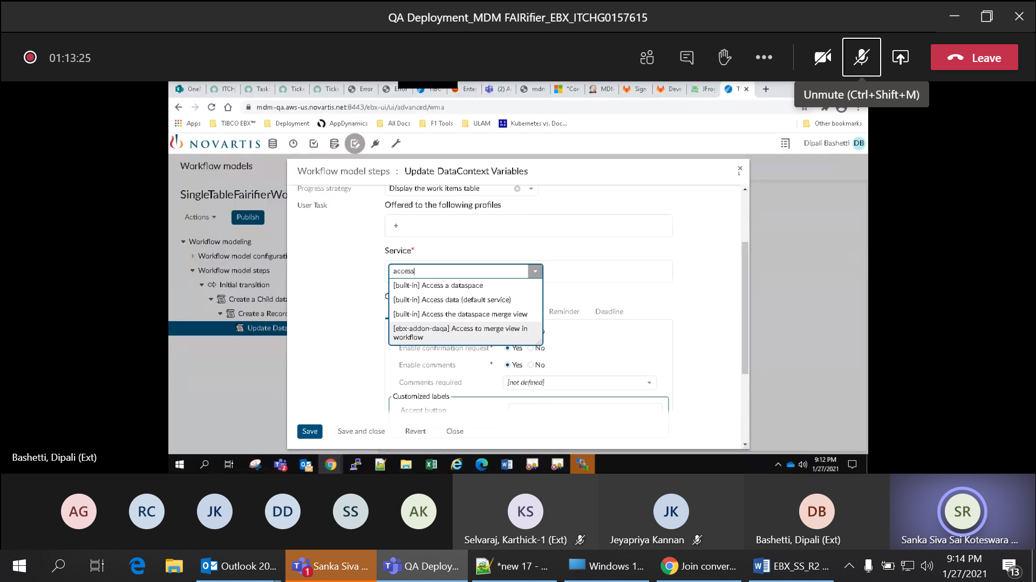

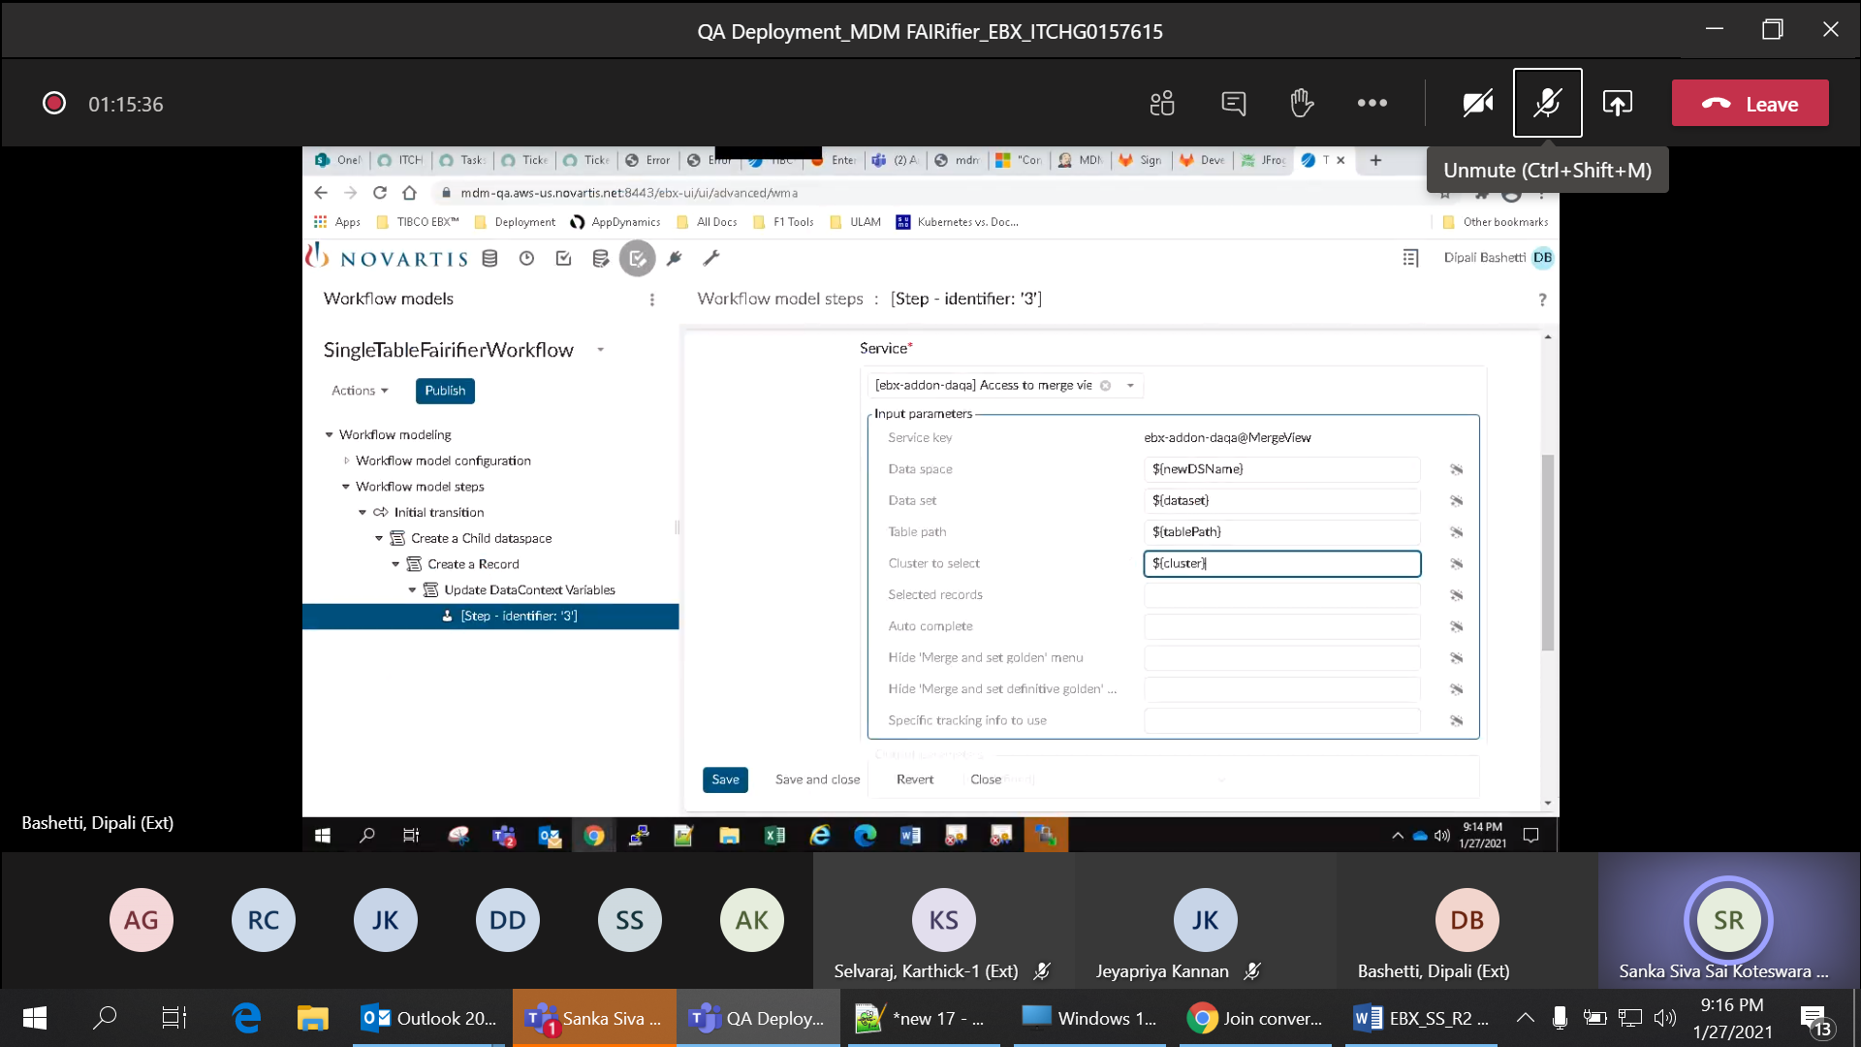

Row no 10: Validate script task is created for updating merged record column in the single table workflow

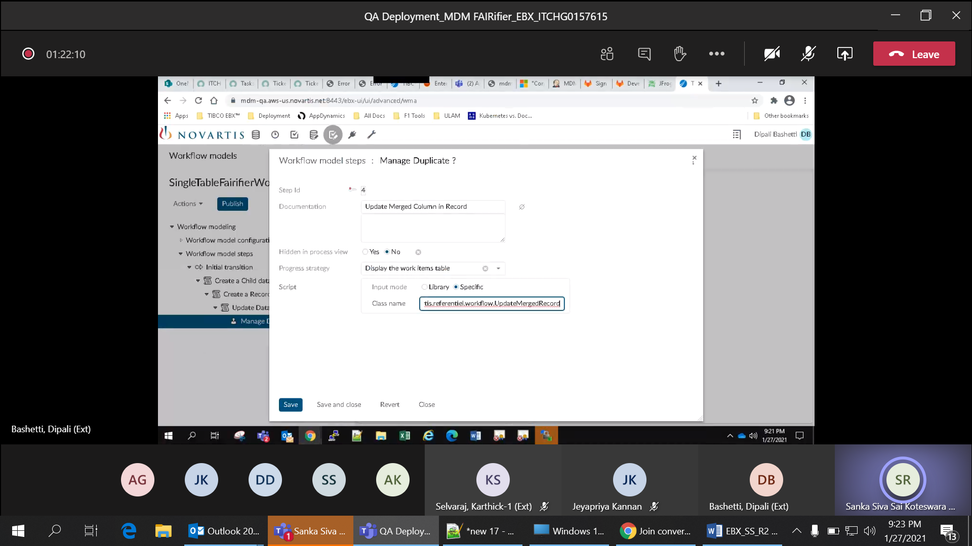

Row no 11: Validate script task for merging the child dataspace with main dataspace

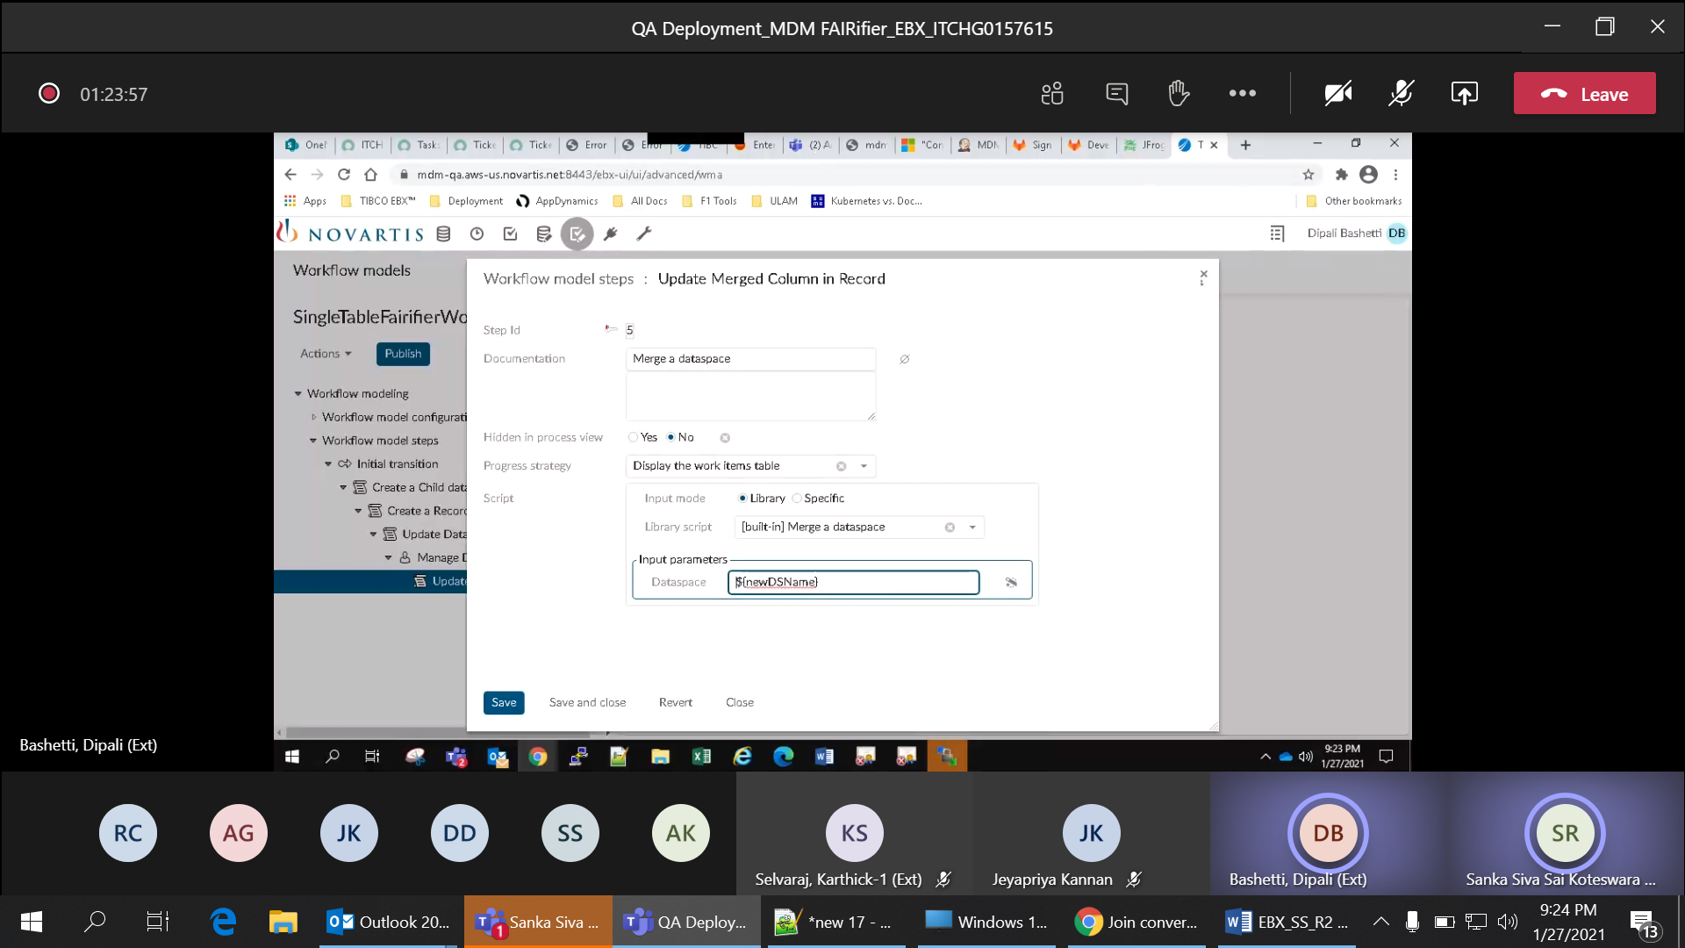

Row no 12: Verify sub-workflow is created for the module - 'novartis-mdm-F1_MDMFairifier' with workflow name - 'DynamicMergeView'

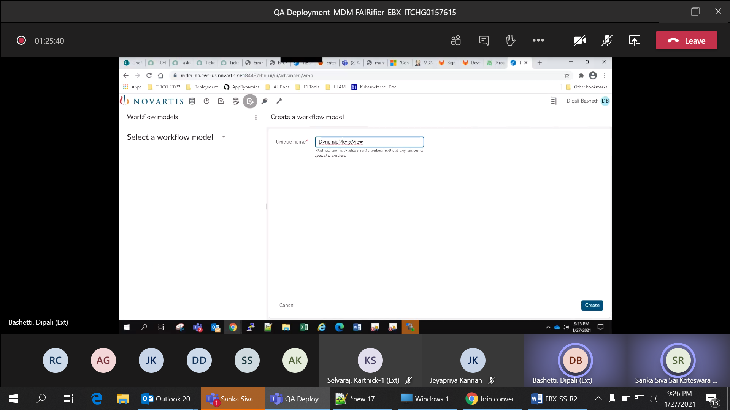

Row no 13: Verify data quality stewardship is created by the script task with rule - 'com.novartis.referentiel.workflow.MultiTableUserTask'

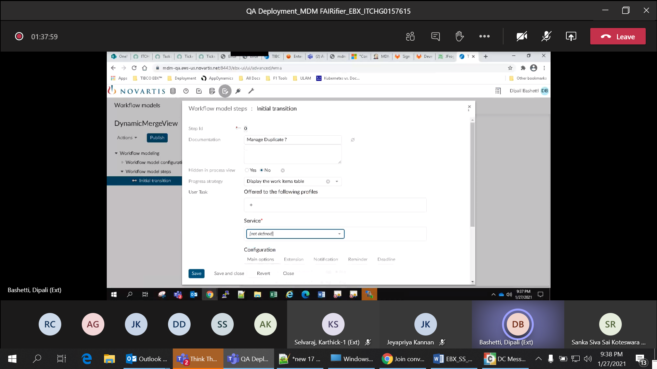

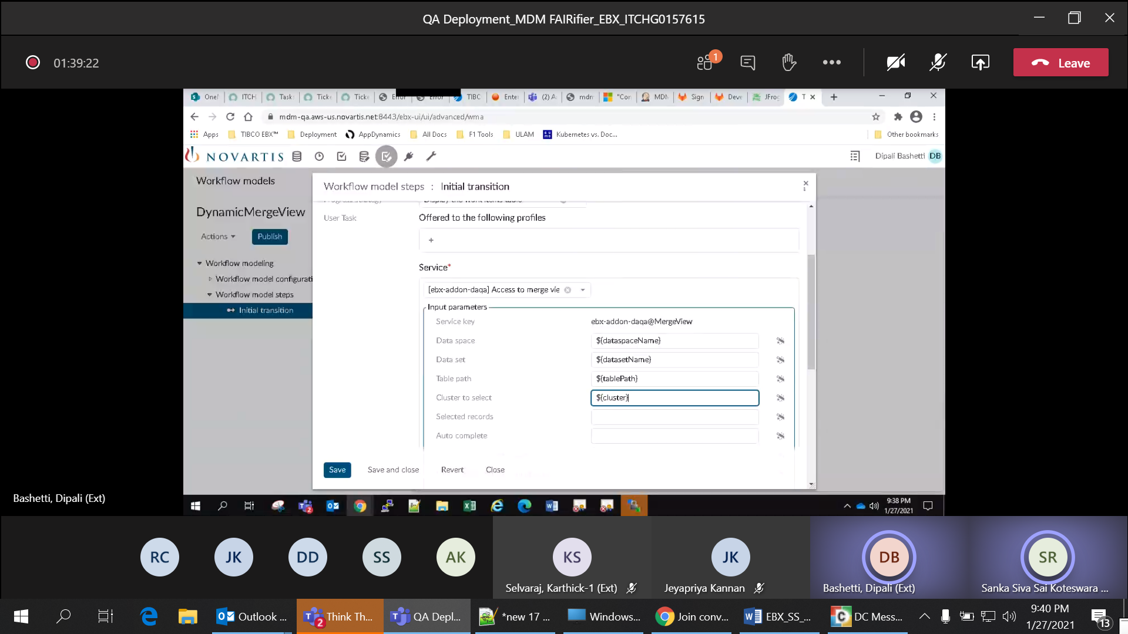

Row no14: Verify data context variables are updated by class name - 'com.novartis.referentiel.workflow.UpdateSubWorkflowContextVariables' in workflow

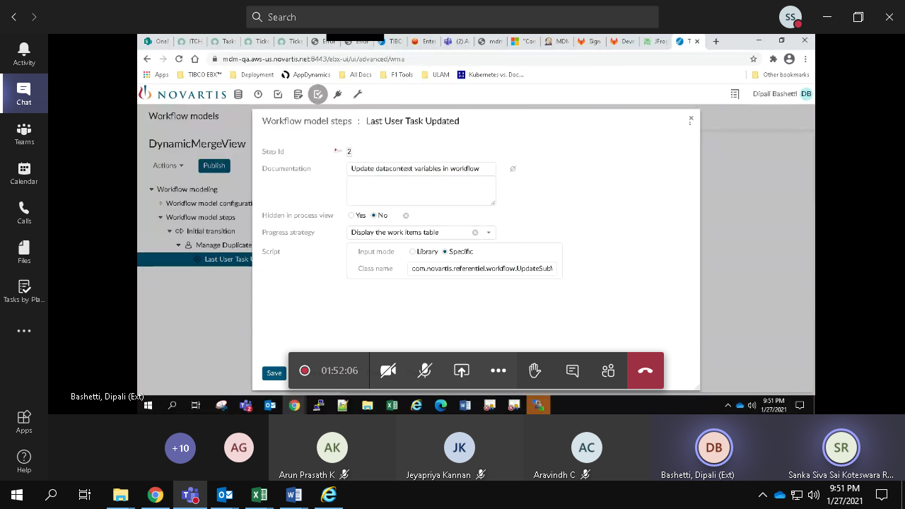

Row no 15: Verify script task for updating merged record column in the single table workflow

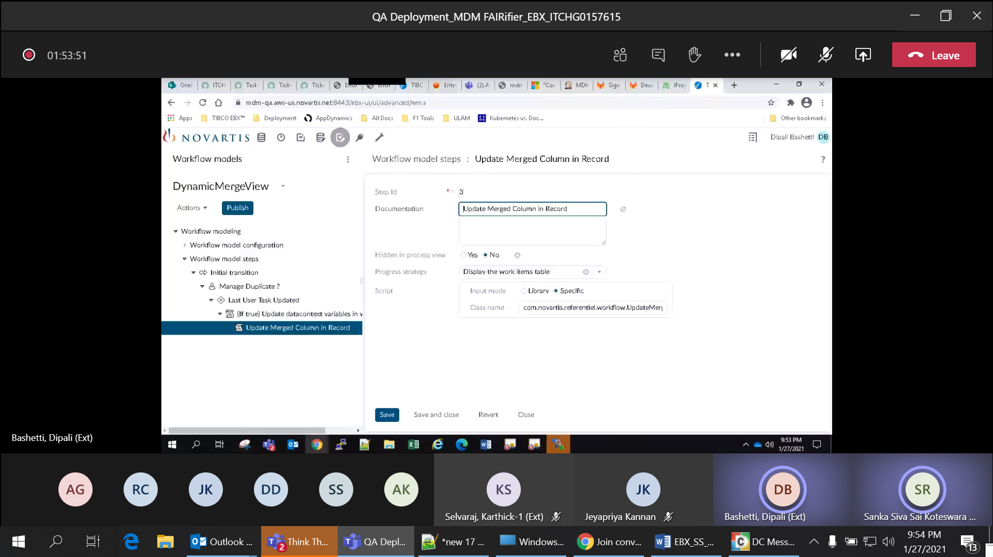

Row no 16: Verify multi table fairifier workflow with module - 'novartis-mdm-F1_MDMFairifier'

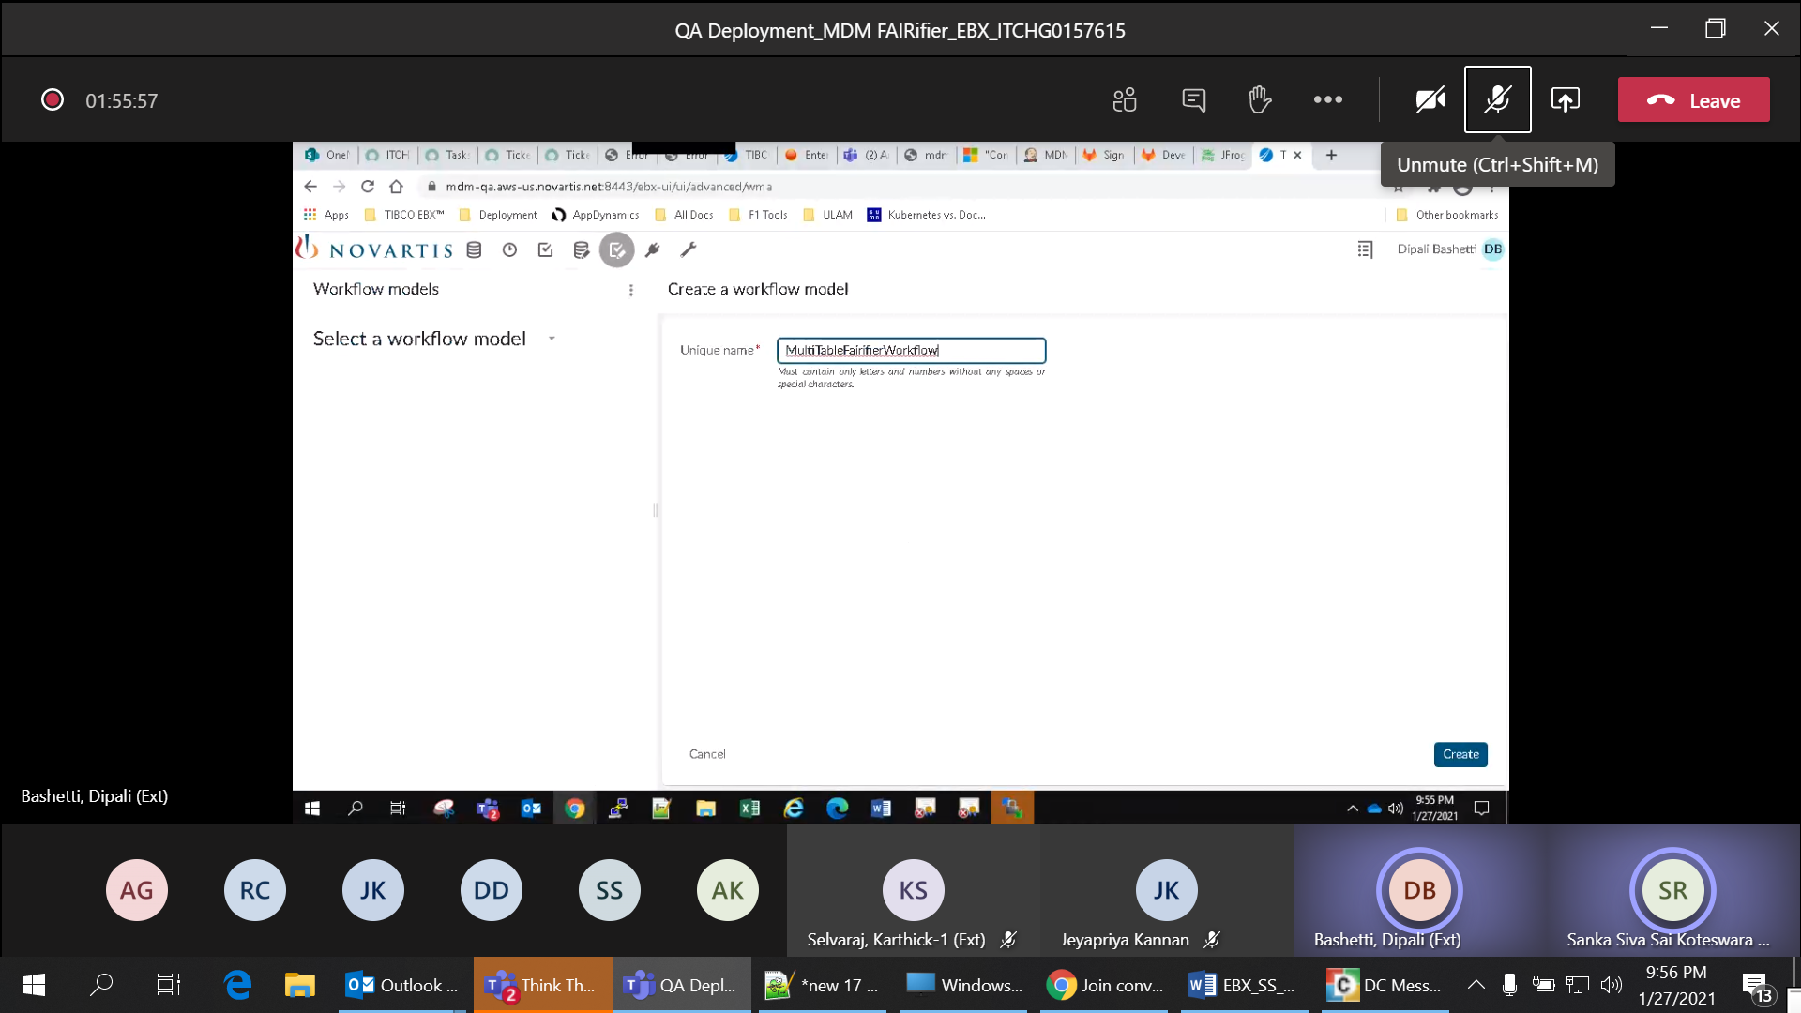

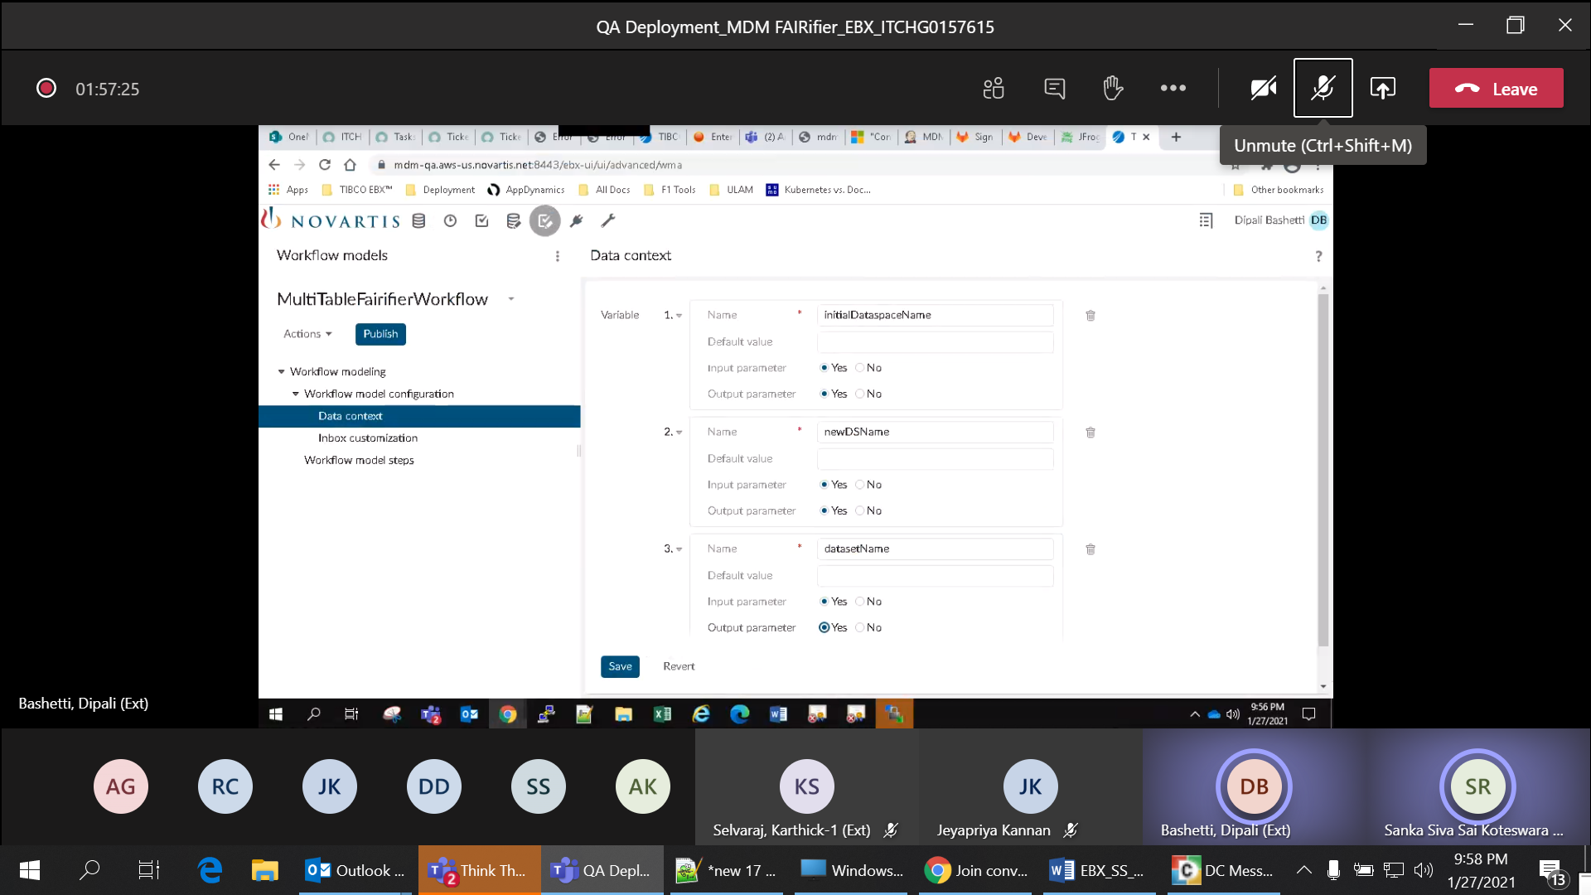

Row no 17: Verify child dataspace is created by script task with input mode - 'Library', library script - '[built-in] Create a dataspace'

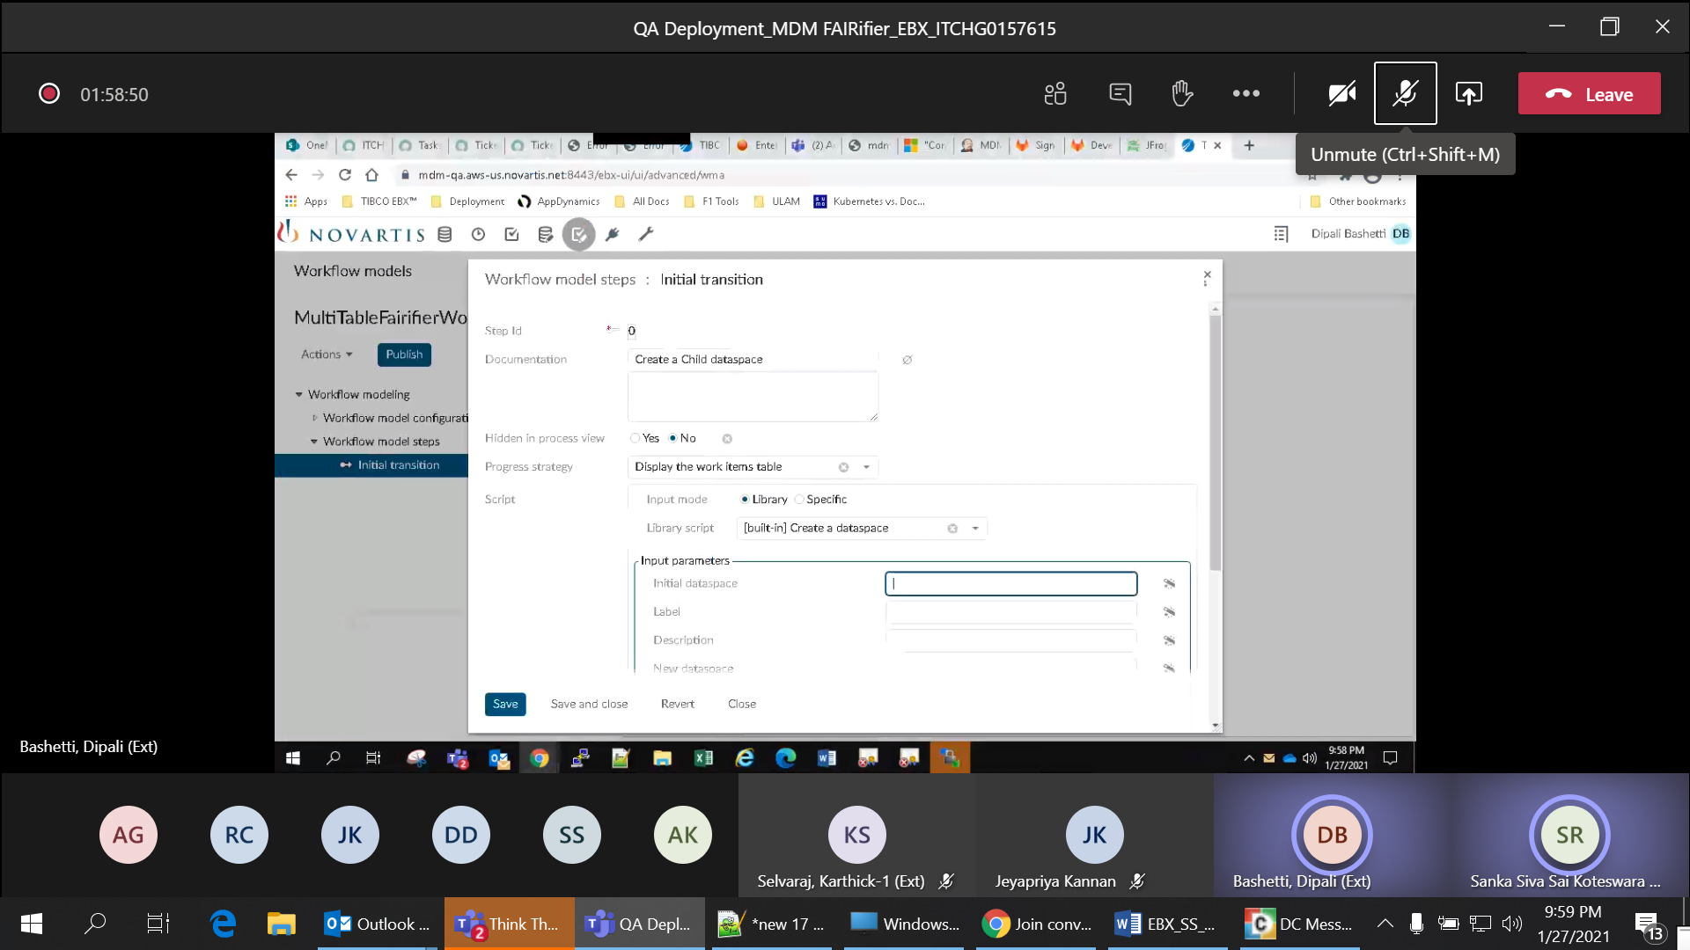

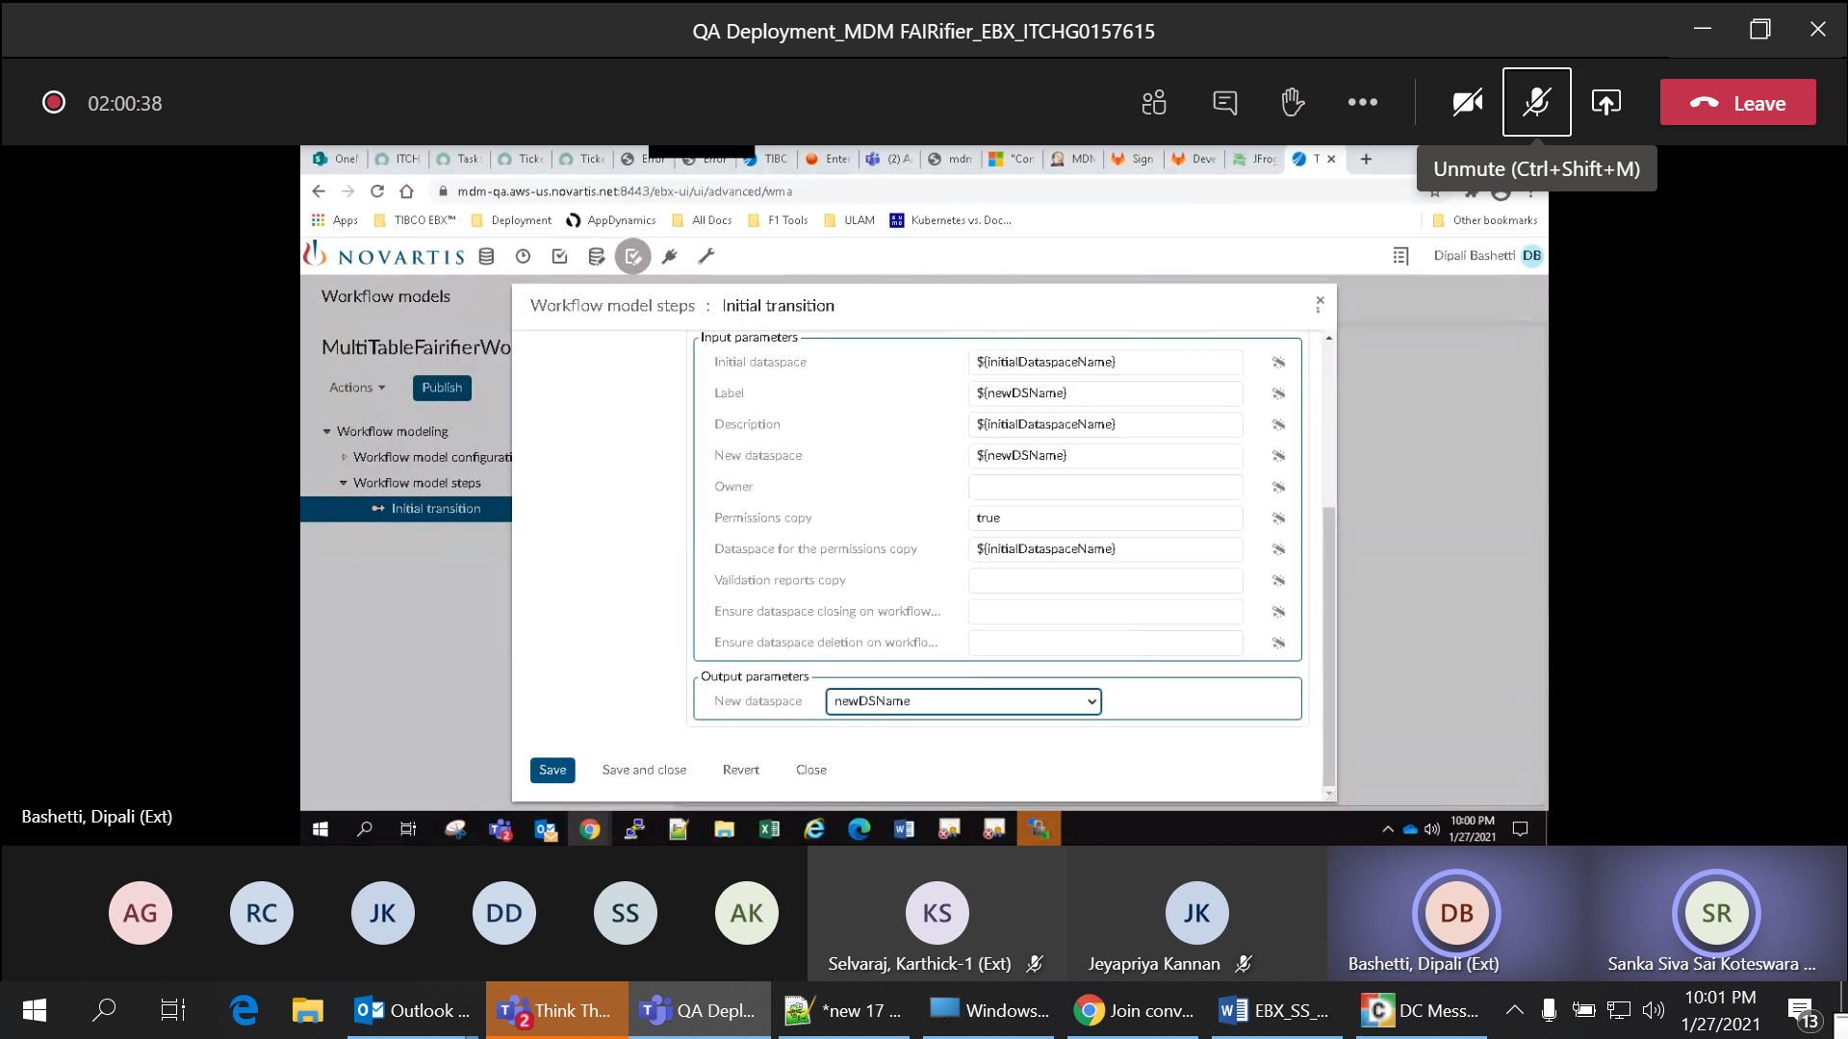

Row no 18: Verify records are created programmatically by the script and class name - 'com.novartis.referentiel.workflow.CreateDatasetRecordScriptTask'

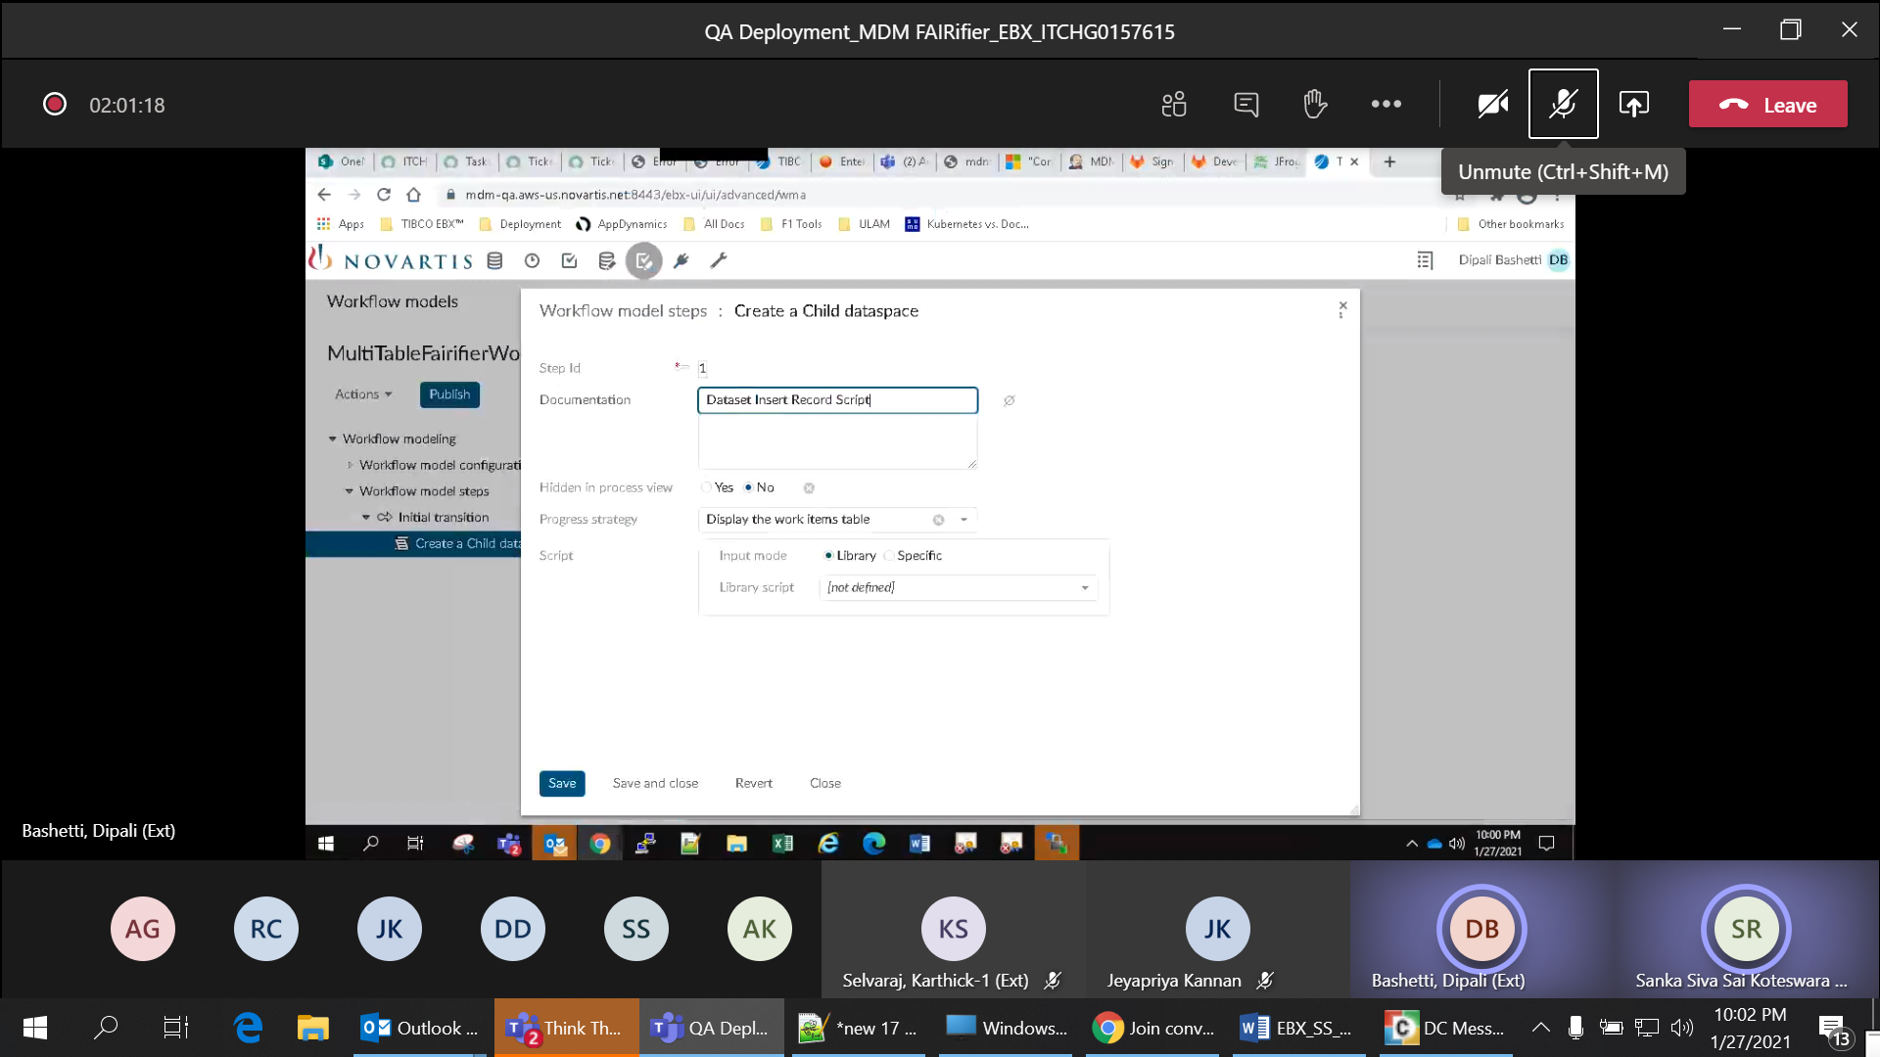

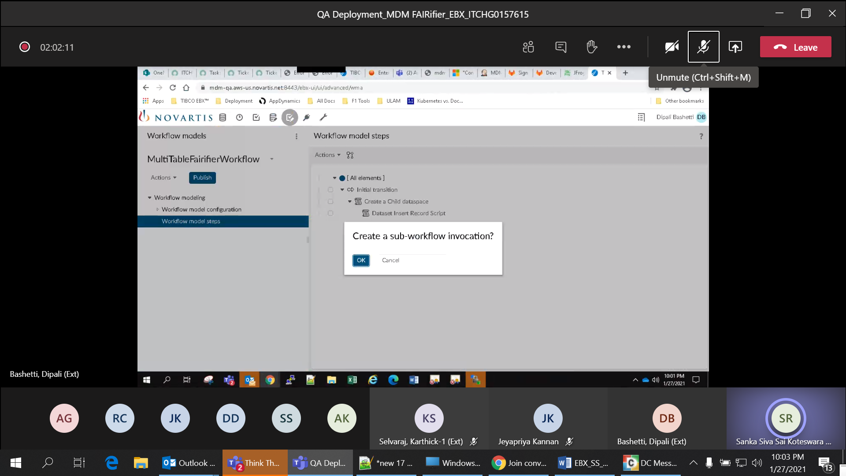

Ron no 19: Verify sub-workflow is created for managing duplicates in child tables



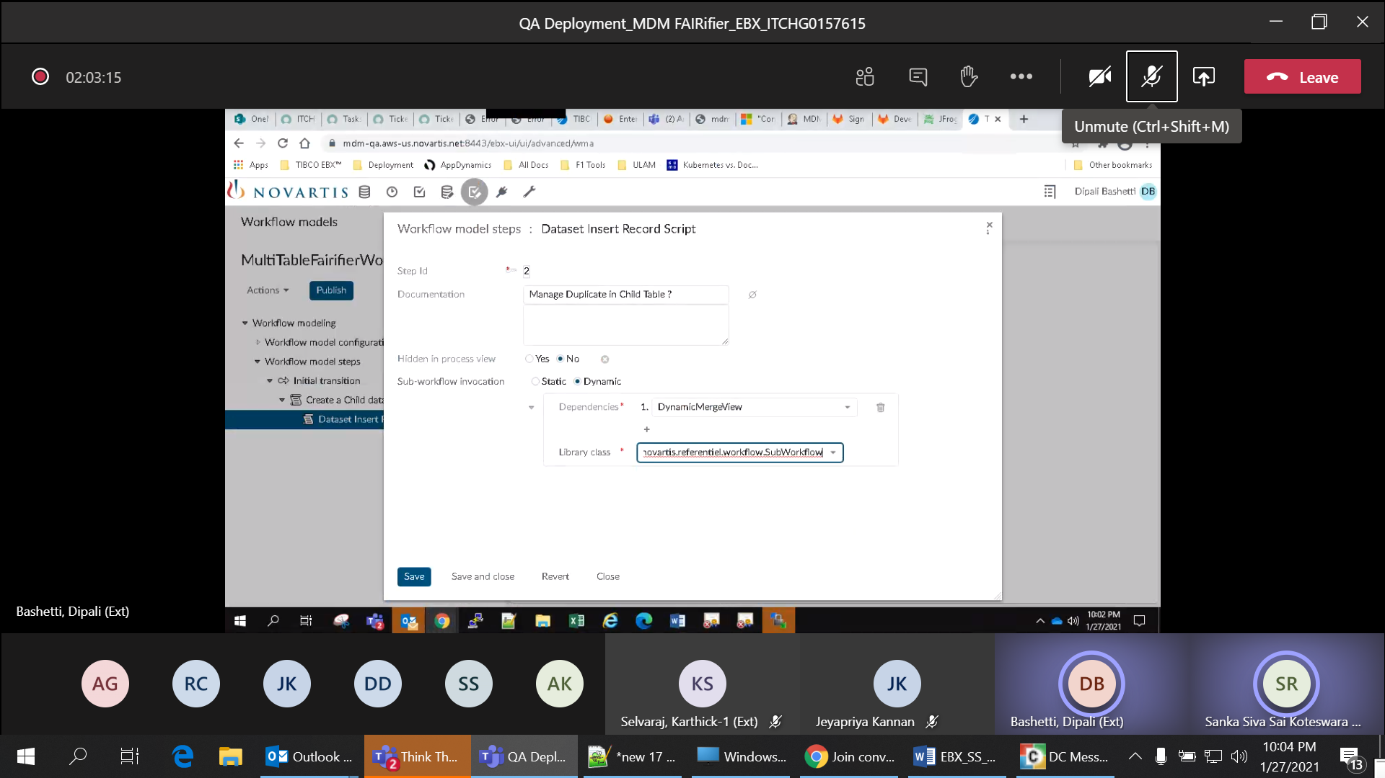

Row no 20: Verify script task for merging the child dataspace with main dataspace

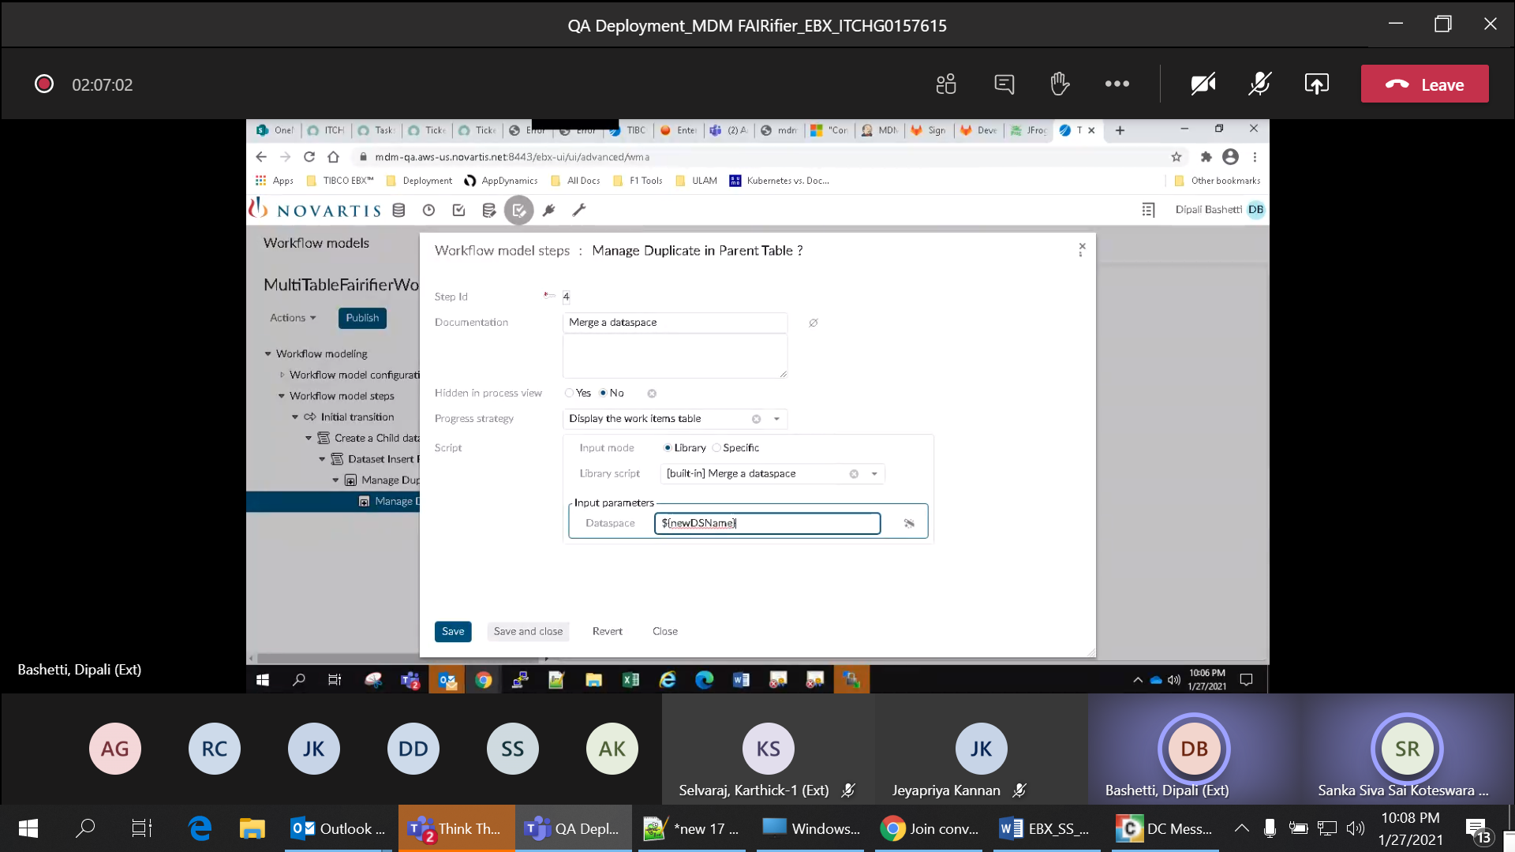

Row no 21: Verify elastic indices are available for each dataset with dataset specific index name

Row no 22: Verify Export ID is created for each dataset and It should be used throughout the job

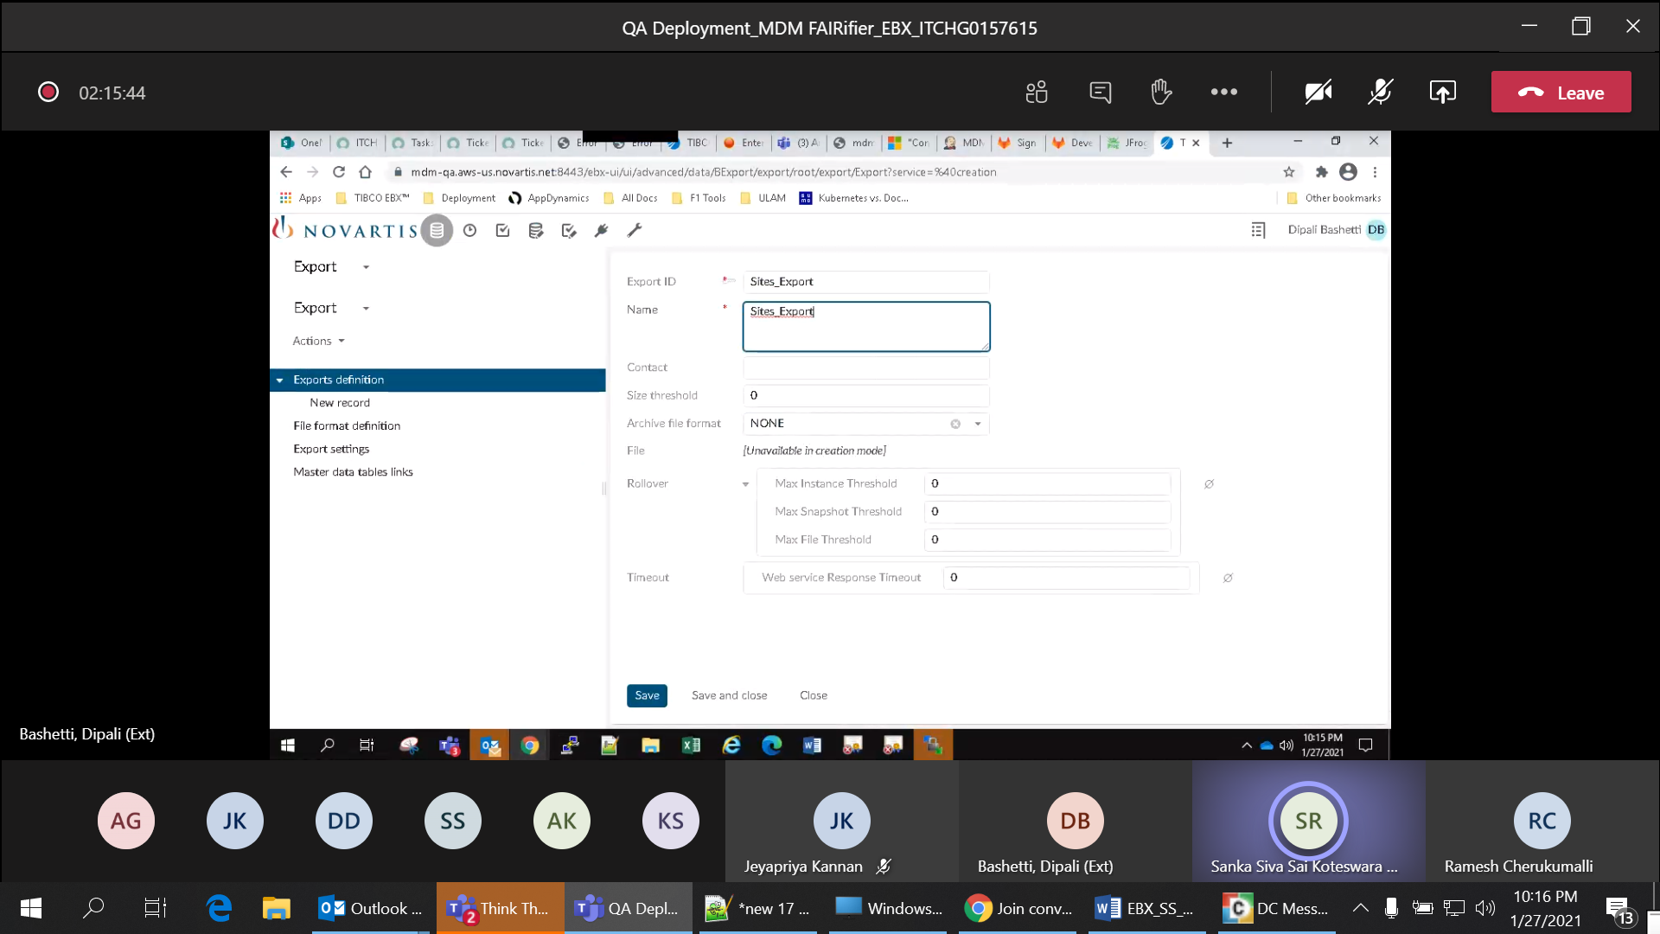

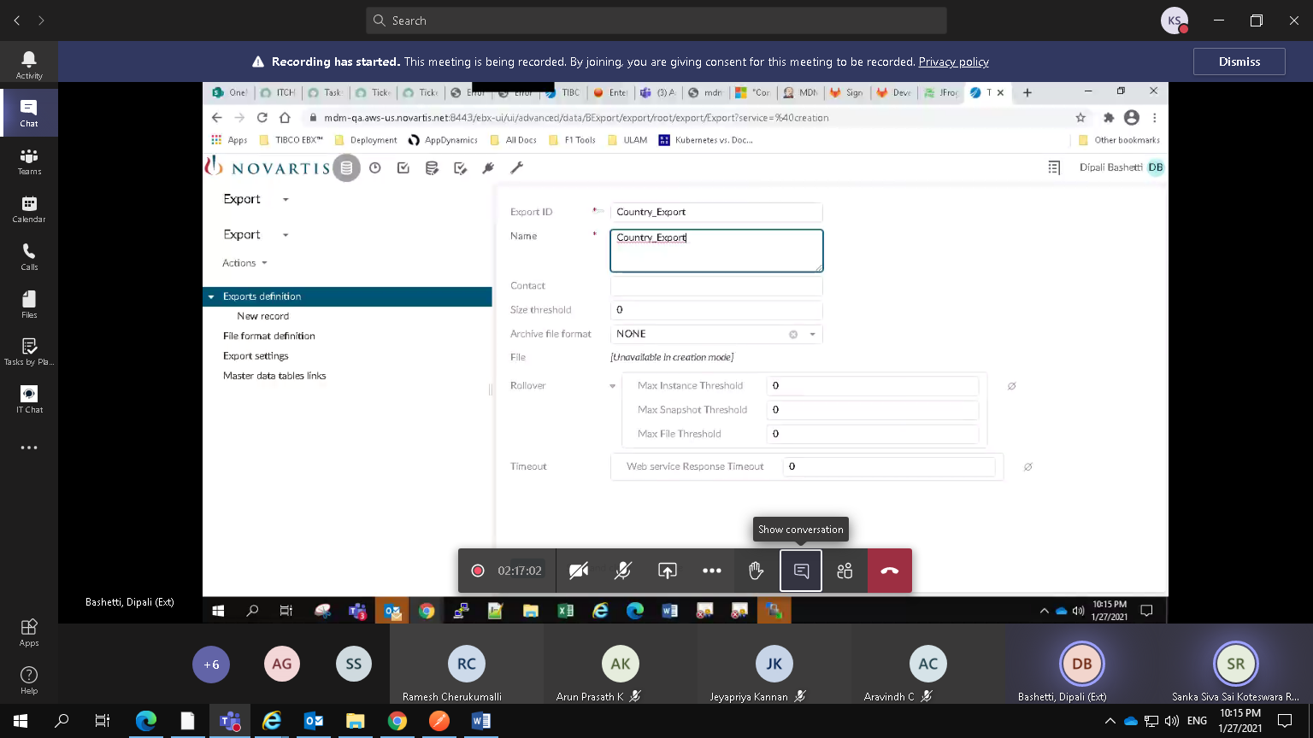

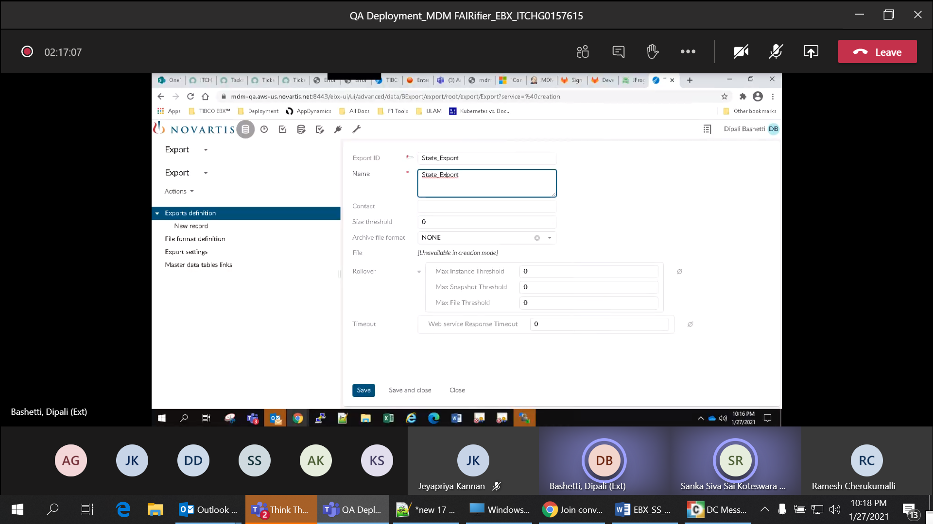

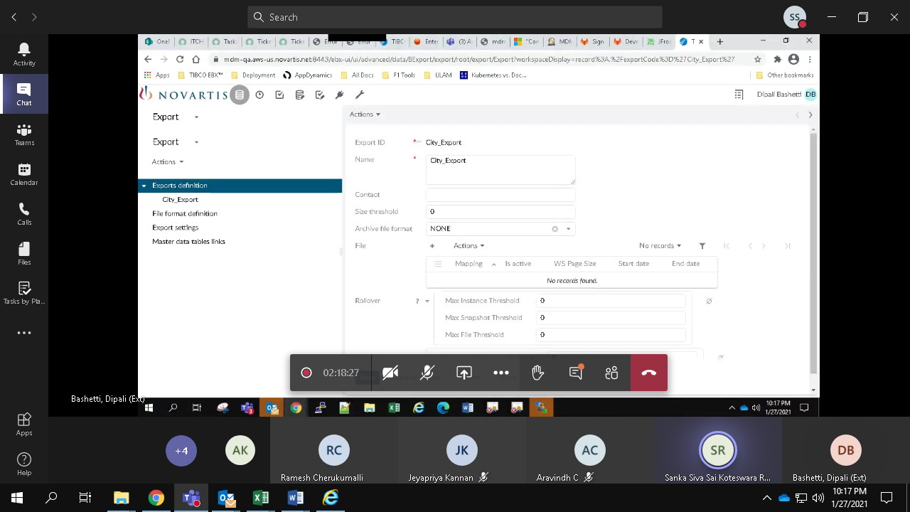

Rown no 23: Verify file format definition is created for the field level mapping with dataspace name, dataset name, File format, master table name

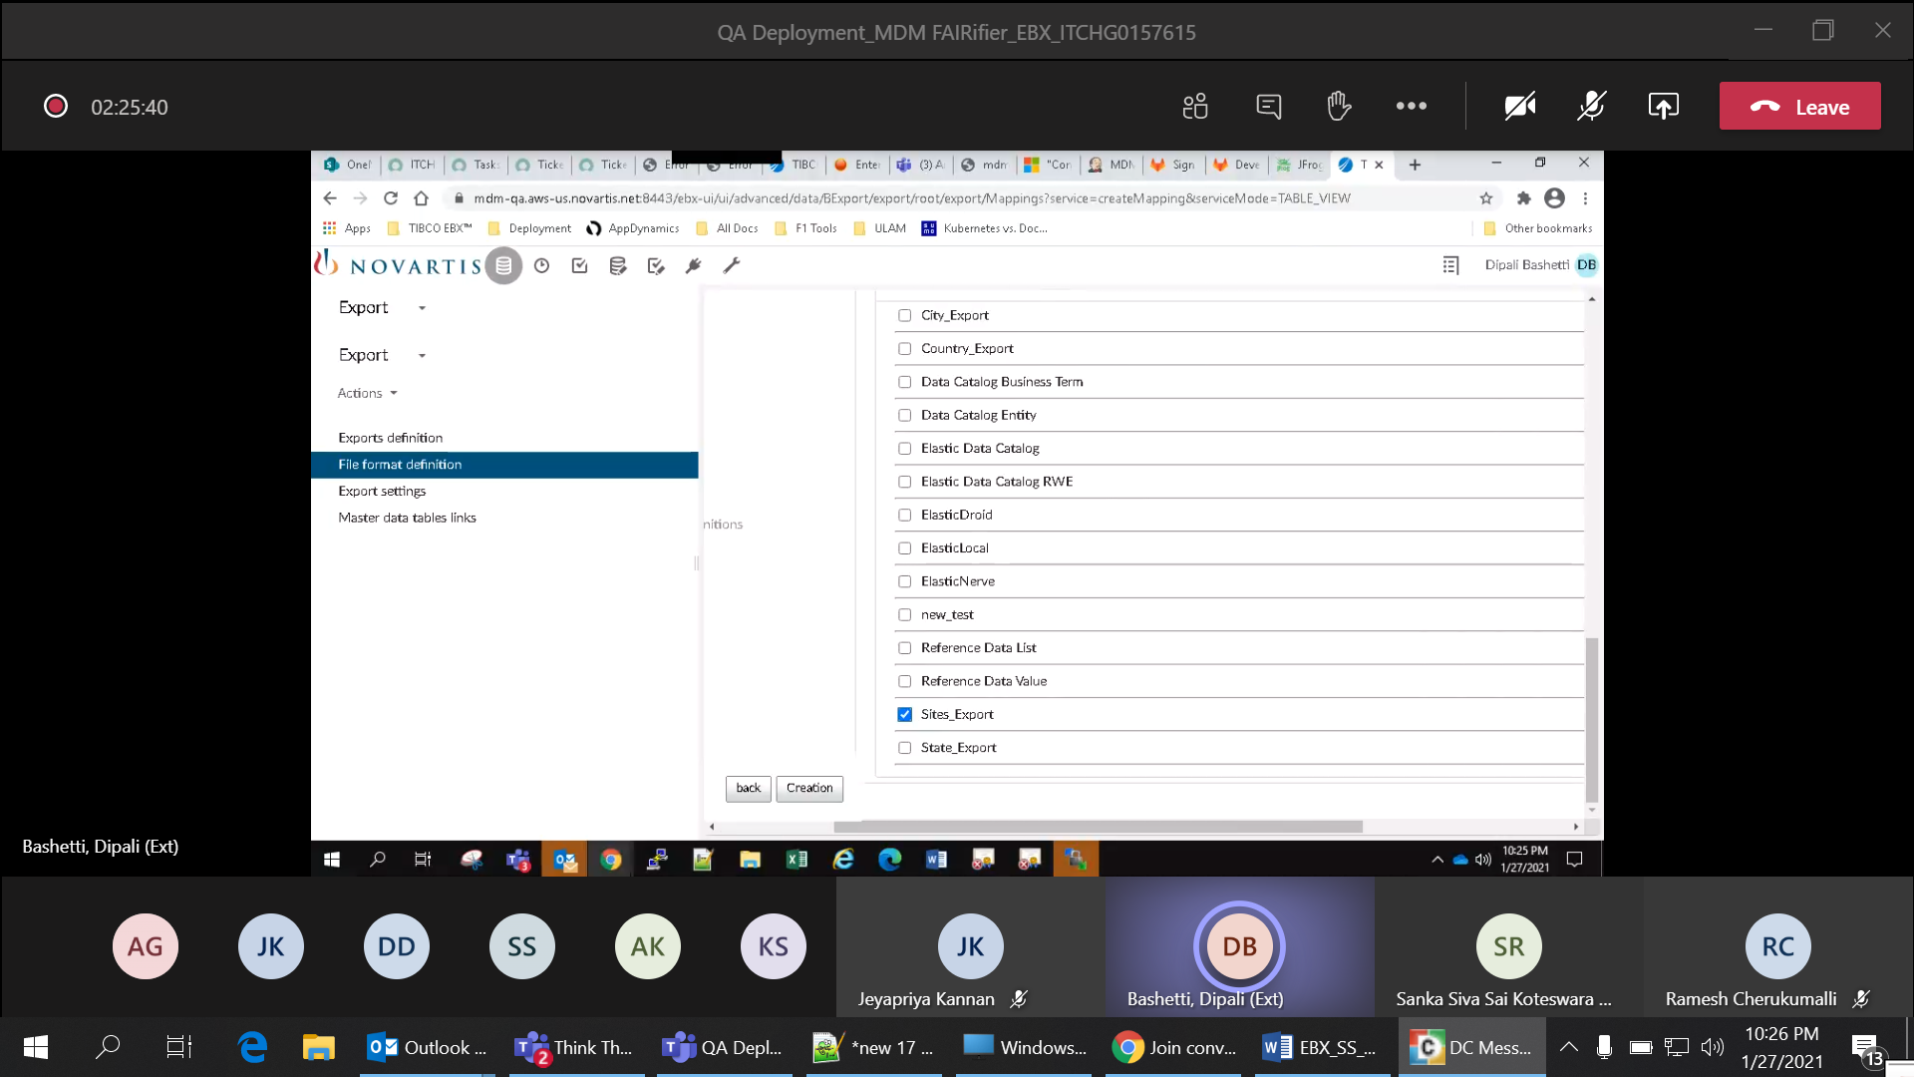

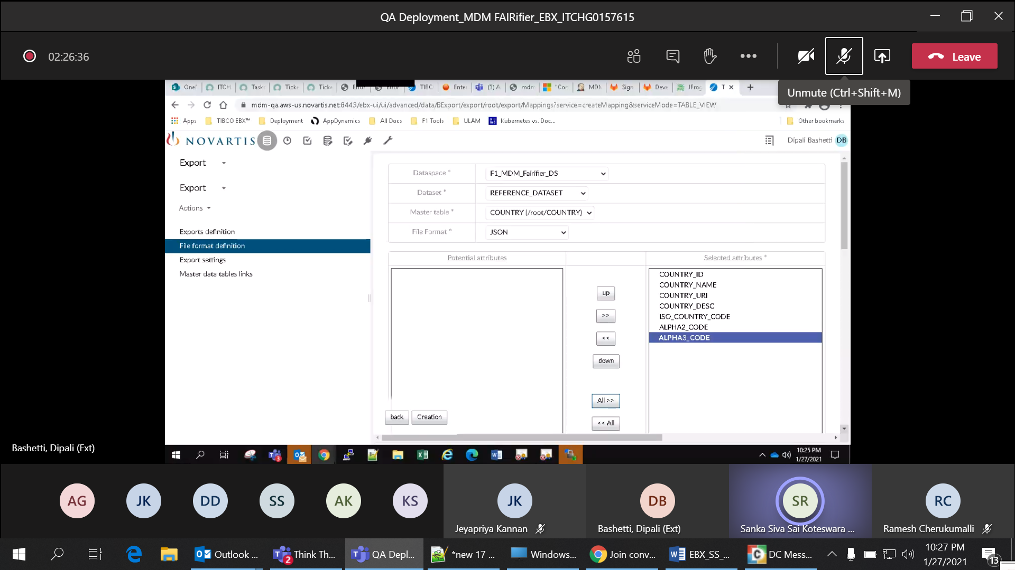

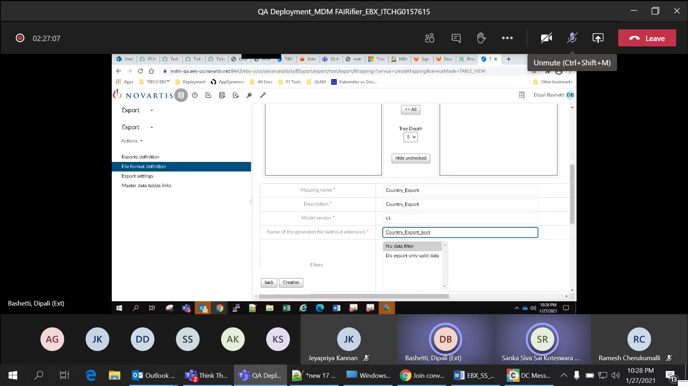

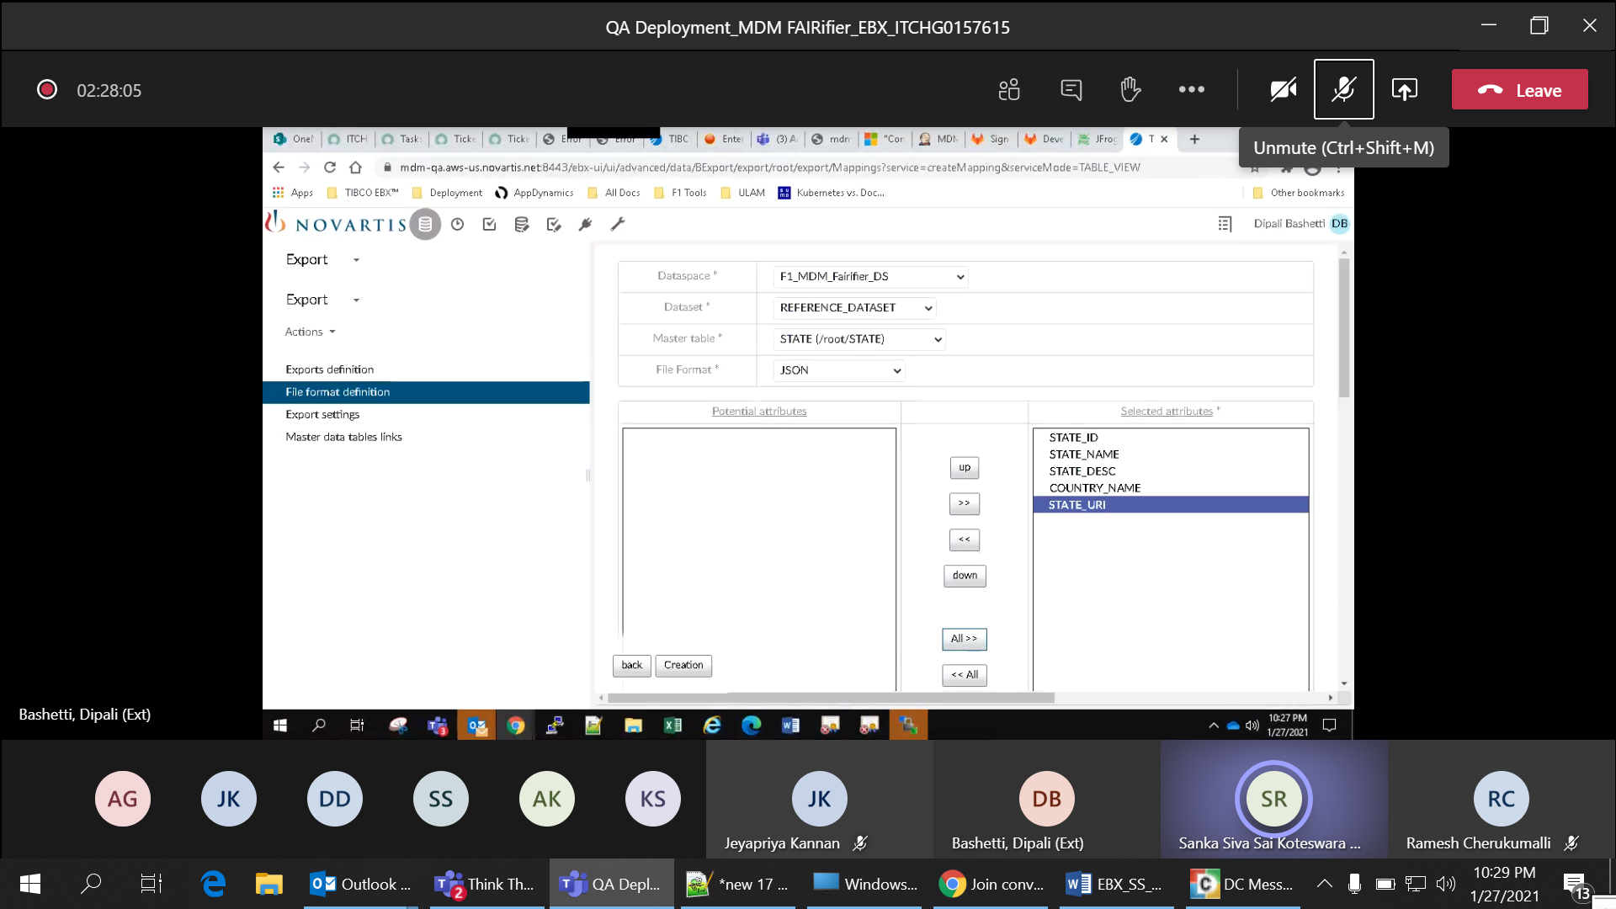

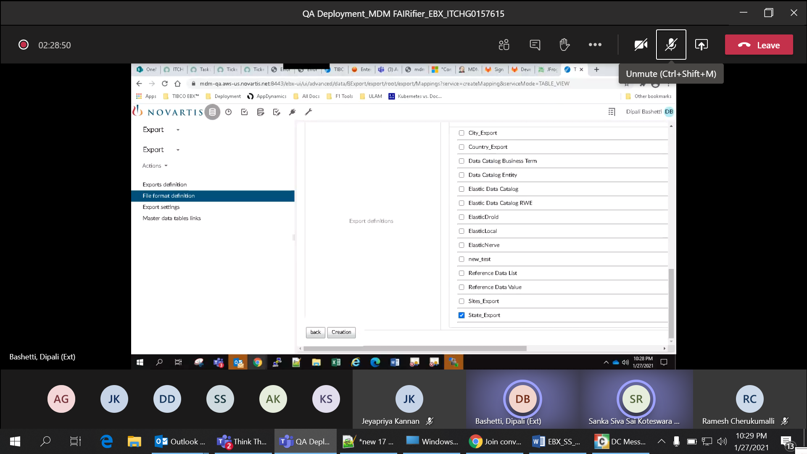

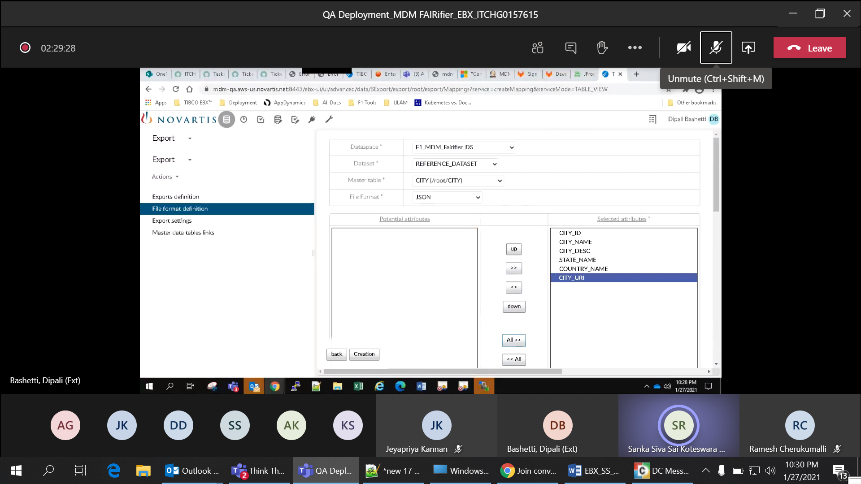

Row no 24: Verify target Elasticsearch export module is configured for task scheduler job with exportId, endpoint, export mapping and Elastic index name

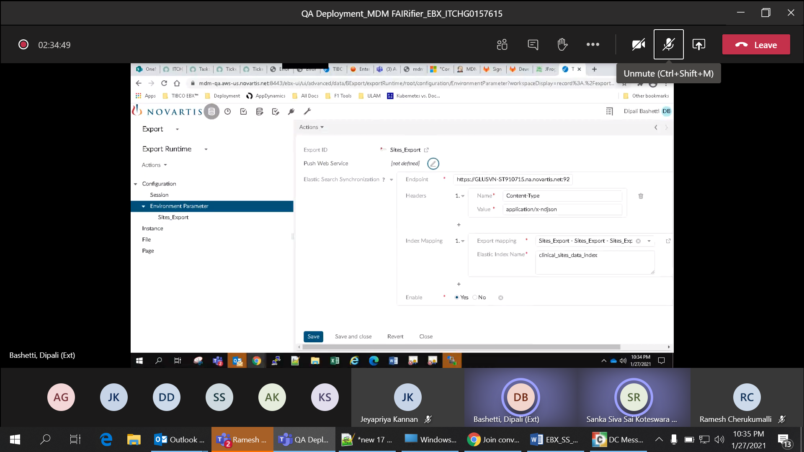

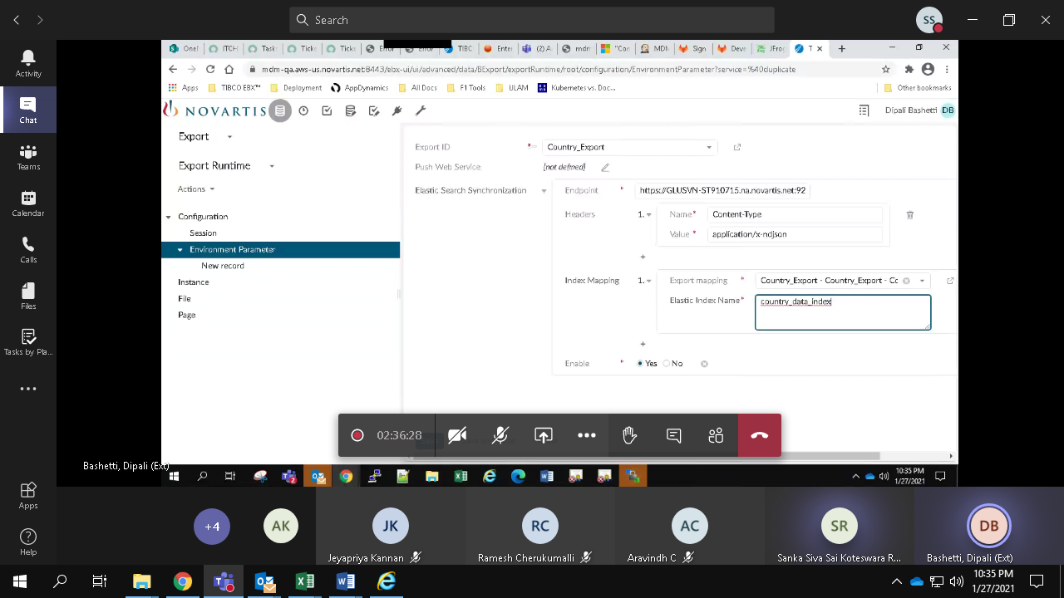

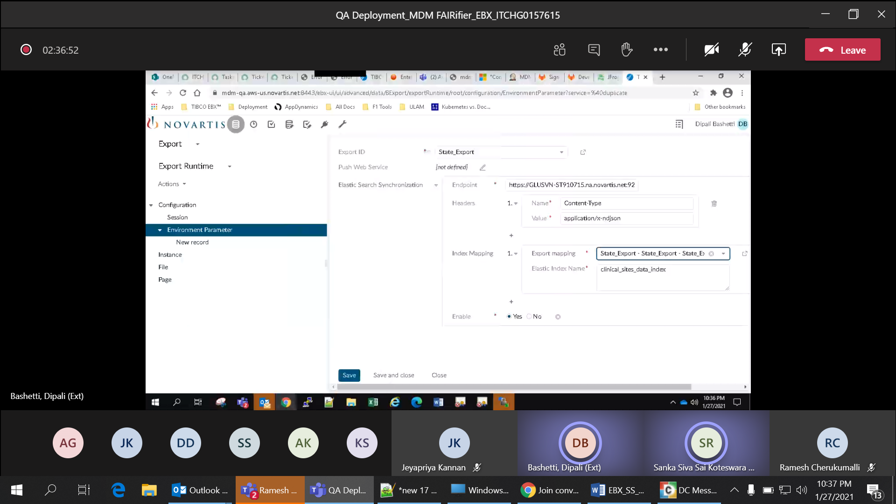

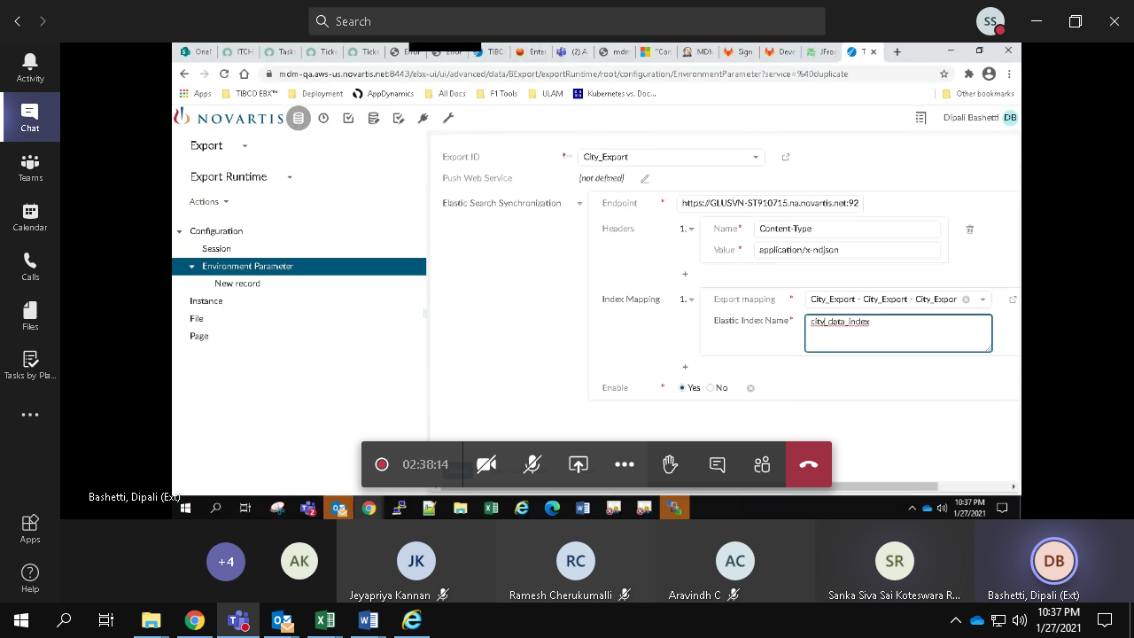

Row no 25: Verify a job is scheduled to export data from EBX to Elastic index

